**JAVA SWING BASED – College Network Hardware Database - SQL CONNECTIVITY USING JDBC**

*A*

*Report*

*Submitted in partial fulfillment of the Requirements for the award of the Degree of*

**BACHELOR OF ENGINEERING IN**

**INFORMATION TECHNOLOGY**

**By**

### T.Vishnu Vardhan Reddy<1602-20-737-060>

**Under the guidance of Ms B. Leelavathy**



### Department of Information Technology Vasavi College of Engineering (Autonomous) (Affiliated to Osmania University) Ibrahimbagh, Hyderabad-31

**2020-2021**

BONAFIDE CERTIFICATE

This is to certify that this project report titled

***‘College Network Hardware database’***

is a project work of **T Vishnu Vardhan Reddy** bearing roll no. 1602-20-737-060 who carried out this project under my supervision in the IV semester for the academic year 2020- 2021

Signature Signature

External Examiner Internal Examiner

# ABSTRACT

In this project, we have to create a database where it has the details of hardware devices which are in use in the college.This database is useful for a college where they can see all the details of hardware devices which are used in each department of college .To implement this database records and to display all the data on the screen we need to build this database with details of hardware devices (like hub,switches,router..etc),department and college as the tables in the database . To build this database, we are using Run SQL for the backend and java for the frontend part.

# Requirement Analysis

## List of Tables:

* College
* Department
* Devices

## List of Attributes with their Domain Types:

College

* + College_id varchar(5)
  + College_name varchar(20)
  + Address varchar(20)

Department

* + Dept_id varchar(20)
  + Dept_name varchar(20)

Devices

* + Device_id varchar(10)
  + Device_type varchar(20)
  + Status varchar(20)
  + Dept_id varchar(20)

# AIM AND PRIORITY OF THE PROJECT

To create a **Java GUI-based** desktop application that connects college network hardware database. It calculates the hardware devices in use in the college network. It takes values like device id, device type, Status, Department id, etc through forms which are then updated in the database using JDBC connectivity

.

**DESIGN**

**Entity Relationship Diagram**

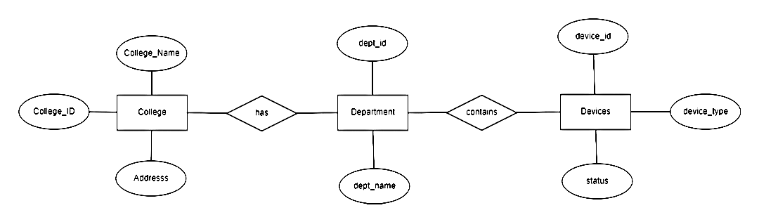

# DATABASE DESIGN

### DDL Operations

1.Create table College(

College_id Number(5),

College_name varchar(20),

Address varchar(20),

PRIMARY KEY (college_ID));

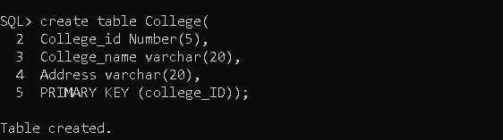

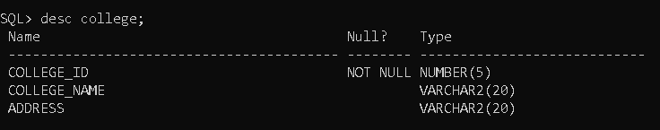

2.Create table dept(

dept_id varchar(20),

dept_name varchar(20),

PRIMARY KEY (dept_ID));

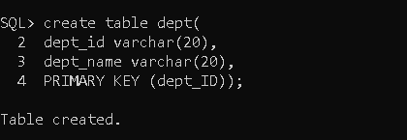

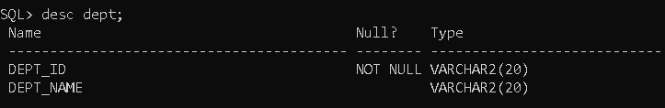

3.Create table devices(

device_id varchar(10),

device_type varchar(20),

status varchar(20),

dept_id varchar(20),

PRIMARY KEY (device_ID));

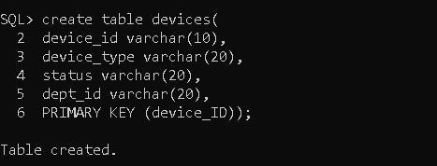

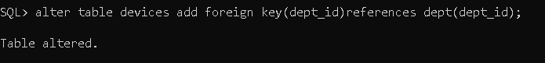

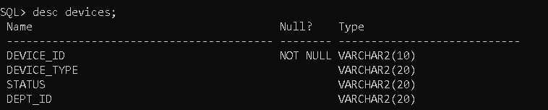

### DML Operations

1.insert into college values('&college_id','&college_name','&address');

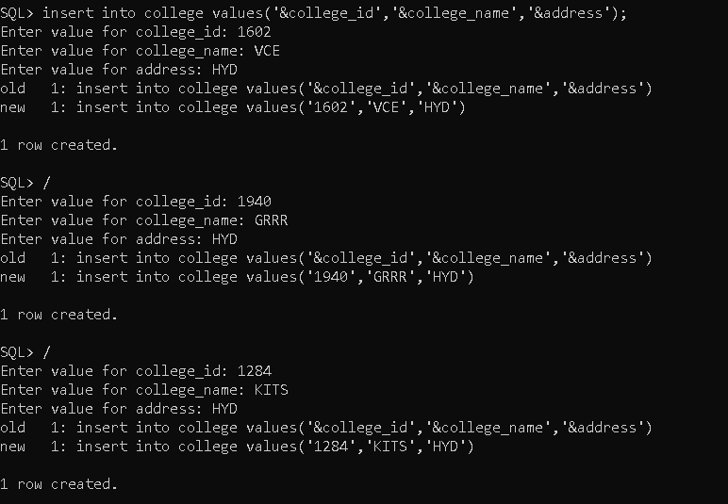

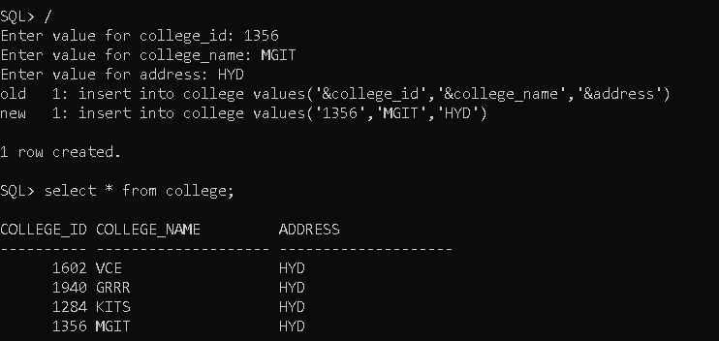

2.insert into dept values('&dept_id','&dept_name');

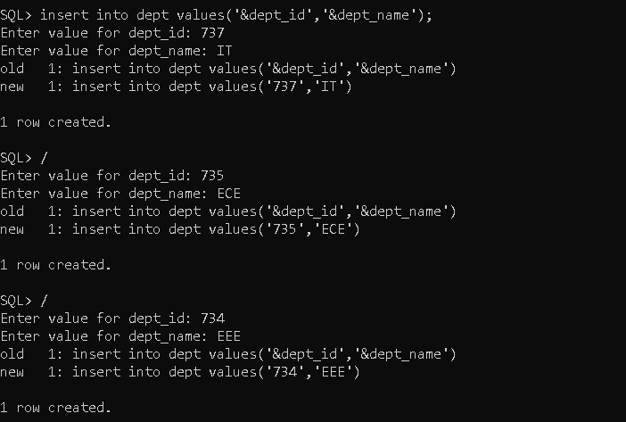

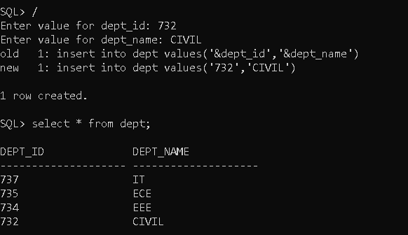

3.inset into devices values('&device_id','&device_type','&status','&dept_id');

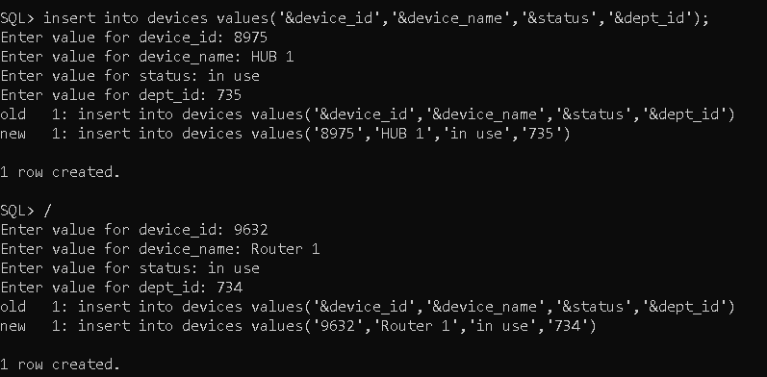

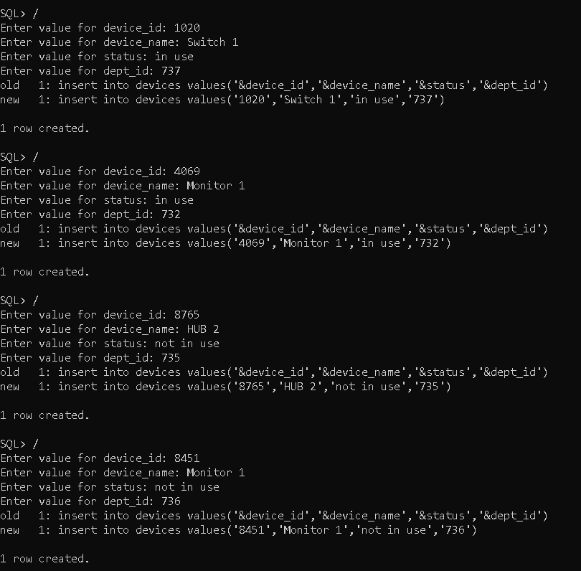

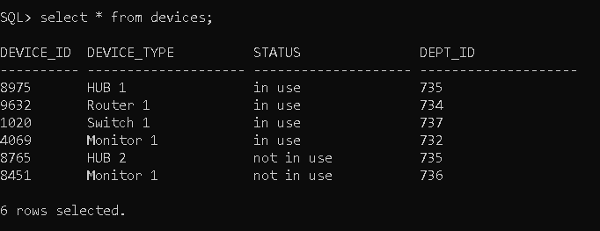

# IMPLEMENTATION

### JAVA-SQL Connectivity using JDBC:

**Java Database Connectivity (JDBC)** is an application programming interface (API) for the programming language Java, which defines how a client may access a database. It is a Java-based data access technology used for Java database connectivity. It is part of the Java Standard Edition platform, from Oracle Corporation. It provides methods to query and update data in a database and is oriented towards relational databases.

The connection to the database can be performed using Java programming (JDBC API) as:

public void connectToDB()

{

try

{

connection

=

DriverManager.getConnection("jdbc:oracle:thin:@localhost:1521:xe","vishnu","vasavi123");

statement = connection.createStatement();

}

catch (SQLException connectException)

{

System.out.println(connectException.getMessage());

System.out.println(connectException.getSQLState()

);

System.out.println(connectException.getErrorCode());

System.exit(1);

}

}

**Front-end Programs(User Interfaces)**

**Home Page:**

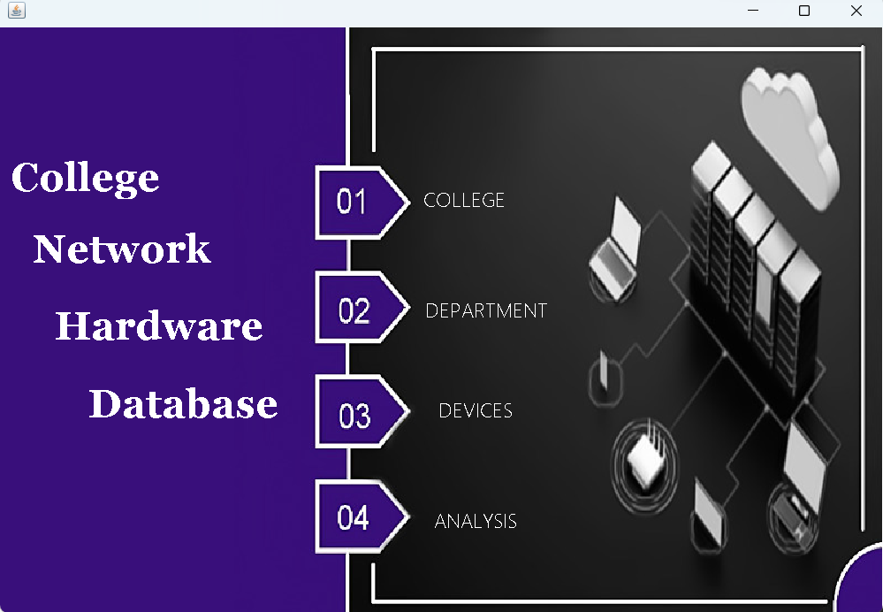

package hardware.database;

public class MAIN extends javax.swing.JFrame {

public MAIN() {

initComponents();

}

private void initComponents() {

jLabel2 = new javax.swing.JLabel();

jButton1 = new javax.swing.JButton();

jButton2 = new javax.swing.JButton();

jButton3 = new javax.swing.JButton();

jButton4 = new javax.swing.JButton();

jLabel3 = new javax.swing.JLabel();

jLabel4 = new javax.swing.JLabel();

jLabel5 = new javax.swing.JLabel();

jLabel1 = new javax.swing.JLabel();

setDefaultCloseOperation(javax.swing.WindowConstants.EXIT_ON_CLOSE);

getContentPane().setLayout(new org.netbeans.lib.awtextra.AbsoluteLayout());

jLabel2.setFont(new java.awt.Font("Georgia", 1, 36)); // NOI18N

jLabel2.setForeground(new java.awt.Color(255, 255, 255));

jLabel2.setText("Hardware");

getContentPane().add(jLabel2, new org.netbeans.lib.awtextra.AbsoluteConstraints(50, 240, 200, 60));

jButton1.setFont(new java.awt.Font("Yu Gothic UI Light", 0, 18)); // NOI18N

jButton1.setForeground(new java.awt.Color(255, 255, 255));

jButton1.setText("COLLEGE");

jButton1.setBorderPainted(false);

jButton1.setContentAreaFilled(false);

jButton1.addActionListener(new java.awt.event.ActionListener() {

public void actionPerformed(java.awt.event.ActionEvent evt) {

jButton1ActionPerformed(evt);

}

});

getContentPane().add(jButton1, new org.netbeans.lib.awtextra.AbsoluteConstraints(340, 130, 160, 50));

jButton2.setFont(new java.awt.Font("Yu Gothic UI Light", 0, 18)); // NOI18N

jButton2.setForeground(new java.awt.Color(255, 255, 255));

jButton2.setText("DEPARTMENT");

jButton2.setBorderPainted(false);

jButton2.setContentAreaFilled(false);

jButton2.addActionListener(new java.awt.event.ActionListener() {

public void actionPerformed(java.awt.event.ActionEvent evt) {

jButton2ActionPerformed(evt);

}

});

getContentPane().add(jButton2, new org.netbeans.lib.awtextra.AbsoluteConstraints(350, 230, 180, 50));

jButton3.setFont(new java.awt.Font("Yu Gothic UI Light", 0, 18)); // NOI18N

jButton3.setForeground(new java.awt.Color(255, 255, 255));

jButton3.setText("DEVICES");

jButton3.setBorderPainted(false);

jButton3.setContentAreaFilled(false);

jButton3.addActionListener(new java.awt.event.ActionListener() {

public void actionPerformed(java.awt.event.ActionEvent evt) {

jButton3ActionPerformed(evt);

}

});

getContentPane().add(jButton3, new org.netbeans.lib.awtextra.AbsoluteConstraints(370, 320, 120, 50));

jButton4.setFont(new java.awt.Font("Yu Gothic UI Light", 0, 18)); // NOI18N

jButton4.setForeground(new java.awt.Color(255, 255, 255));

jButton4.setText("ANALYSIS");

jButton4.setBorderPainted(false);

jButton4.setContentAreaFilled(false);

jButton4.addActionListener(new java.awt.event.ActionListener() {

public void actionPerformed(java.awt.event.ActionEvent evt) {

jButton4ActionPerformed(evt);

}

});

getContentPane().add(jButton4, new org.netbeans.lib.awtextra.AbsoluteConstraints(370, 420, 120, 50));

jLabel3.setFont(new java.awt.Font("Georgia", 1, 36)); // NOI18N

jLabel3.setForeground(new java.awt.Color(255, 255, 255));

jLabel3.setText("College ");

getContentPane().add(jLabel3, new org.netbeans.lib.awtextra.AbsoluteConstraints(10, 100, 180, 70));

jLabel4.setFont(new java.awt.Font("Georgia", 1, 36)); // NOI18N

jLabel4.setForeground(new java.awt.Color(255, 255, 255));

jLabel4.setText("Database");

getContentPane().add(jLabel4, new org.netbeans.lib.awtextra.AbsoluteConstraints(80, 310, 180, 60));

jLabel5.setFont(new java.awt.Font("Georgia", 1, 36)); // NOI18N

jLabel5.setForeground(new java.awt.Color(255, 255, 255));

jLabel5.setText("Network ");

getContentPane().add(jLabel5, new org.netbeans.lib.awtextra.AbsoluteConstraints(30, 170, 220, 60));

jLabel1.setIcon(new javax.swing.ImageIcon(getClass().getResource("/hardware/database/MAIN.jpg"))); // NOI18N

getContentPane().add(jLabel1, new org.netbeans.lib.awtextra.AbsoluteConstraints(0, 0, 800, 530));

pack();

}

private void jButton1ActionPerformed(java.awt.event.ActionEvent evt) {

college c = new college ();

c.show();

dispose();

}

private void jButton2ActionPerformed(java.awt.event.ActionEvent evt) {

department d = new department ();

d.show();

dispose();

}

private void jButton3ActionPerformed(java.awt.event.ActionEvent evt) {

device de = new device ();

de.show();

dispose();

}

private void jButton4ActionPerformed(java.awt.event.ActionEvent evt) {

analysis a = new analysis();

a.show();

dispose();

}

public static void main(String args[]) {

java.awt.EventQueue.invokeLater(new Runnable() {

public void run() {

new MAIN().setVisible(true);

}

});

}

private javax.swing.JButton jButton1;

private javax.swing.JButton jButton2;

private javax.swing.JButton jButton3;

private javax.swing.JButton jButton4;

private javax.swing.JLabel jLabel1;

private javax.swing.JLabel jLabel2;

private javax.swing.JLabel jLabel3;

private javax.swing.JLabel jLabel4;

private javax.swing.JLabel jLabel5;

}

**College Table:**

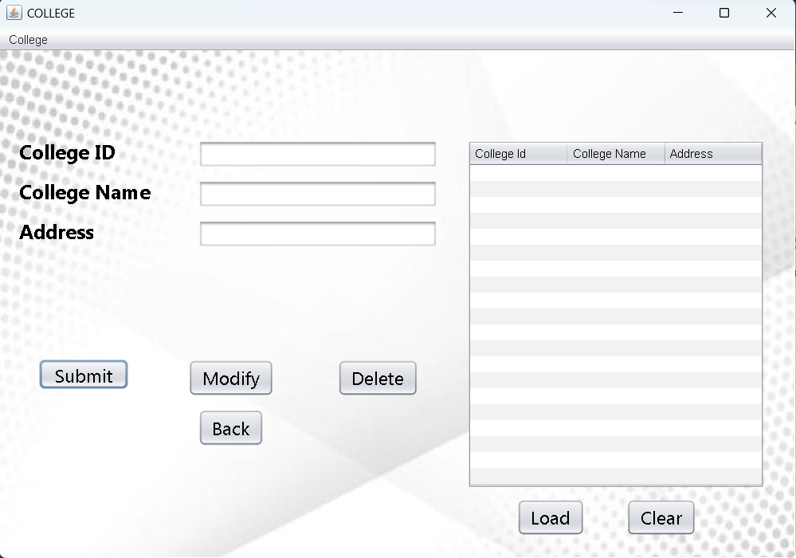

package hardware.database;

import java.sql.Connection;

import java.sql.DriverManager;

import java.sql.ResultSet;

import java.sql.Statement;

import javax.swing.JFrame;

import javax.swing.JOptionPane;

import javax.swing.table.DefaultTableModel;

public class college extends javax.swing.JFrame {

public college() {

initComponents();

}

private void initComponents() {

jMenuItem5 = new javax.swing.JMenuItem();

jLabel1 = new javax.swing.JLabel();

jTextField1 = new javax.swing.JTextField();

jLabel2 = new javax.swing.JLabel();

jLabel3 = new javax.swing.JLabel();

jTextField2 = new javax.swing.JTextField();

jTextField3 = new javax.swing.JTextField();

jButton1 = new javax.swing.JButton();

jButton2 = new javax.swing.JButton();

jButton3 = new javax.swing.JButton();

jButton4 = new javax.swing.JButton();

jButton5 = new javax.swing.JButton();

jScrollPane1 = new javax.swing.JScrollPane();

jTable1 = new javax.swing.JTable();

jLabel5 = new javax.swing.JLabel();

jButton6 = new javax.swing.JButton();

jLabel4 = new javax.swing.JLabel();

jMenuBar1 = new javax.swing.JMenuBar();

jMenu1 = new javax.swing.JMenu();

jMenuItem5.setText("jMenuItem5");

setDefaultCloseOperation(javax.swing.WindowConstants.EXIT_ON_CLOSE);

setTitle("COLLEGE");

getContentPane().setLayout(new org.netbeans.lib.awtextra.AbsoluteLayout());

jLabel1.setFont(new java.awt.Font("Microsoft New Tai Lue", 1, 20)); // NOI18N

jLabel1.setText("College ID");

getContentPane().add(jLabel1, new org.netbeans.lib.awtextra.AbsoluteConstraints(20, 90, 145, -1));

jTextField1.addActionListener(new java.awt.event.ActionListener() {

public void actionPerformed(java.awt.event.ActionEvent evt) {

jTextField1ActionPerformed(evt);

}

});

getContentPane().add(jTextField1, new org.netbeans.lib.awtextra.AbsoluteConstraints(200, 90, 240, -1));

jLabel2.setFont(new java.awt.Font("Microsoft New Tai Lue", 1, 20)); // NOI18N

jLabel2.setText("College Name");

getContentPane().add(jLabel2, new org.netbeans.lib.awtextra.AbsoluteConstraints(20, 130, 145, -1));

jLabel3.setFont(new java.awt.Font("Microsoft New Tai Lue", 1, 20)); // NOI18N

jLabel3.setText("Address");

getContentPane().add(jLabel3, new org.netbeans.lib.awtextra.AbsoluteConstraints(20, 170, 145, -1));

jTextField2.addActionListener(new java.awt.event.ActionListener() {

public void actionPerformed(java.awt.event.ActionEvent evt) {

jTextField2ActionPerformed(evt);

}

});

getContentPane().add(jTextField2, new org.netbeans.lib.awtextra.AbsoluteConstraints(200, 130, 240, -1));

getContentPane().add(jTextField3, new org.netbeans.lib.awtextra.AbsoluteConstraints(200, 170, 240, -1));

jButton1.setFont(new java.awt.Font("Nirmala UI", 0, 18)); // NOI18N

jButton1.setText("Submit");

jButton1.setDoubleBuffered(true);

jButton1.addActionListener(new java.awt.event.ActionListener() {

public void actionPerformed(java.awt.event.ActionEvent evt) {

jButton1ActionPerformed(evt);

}

});

getContentPane().add(jButton1, new org.netbeans.lib.awtextra.AbsoluteConstraints(40, 310, 90, 30));

jButton2.setFont(new java.awt.Font("Nirmala UI", 0, 18)); // NOI18N

jButton2.setText("Modify");

jButton2.addActionListener(new java.awt.event.ActionListener() {

public void actionPerformed(java.awt.event.ActionEvent evt) {

jButton2ActionPerformed(evt);

}

});

getContentPane().add(jButton2, new org.netbeans.lib.awtextra.AbsoluteConstraints(190, 310, -1, -1));

jButton3.setFont(new java.awt.Font("Nirmala UI", 0, 18)); // NOI18N

jButton3.setText("Delete");

jButton3.addActionListener(new java.awt.event.ActionListener() {

public void actionPerformed(java.awt.event.ActionEvent evt) {

jButton3ActionPerformed(evt);

}

});

getContentPane().add(jButton3, new org.netbeans.lib.awtextra.AbsoluteConstraints(340, 310, -1, -1));

jButton4.setFont(new java.awt.Font("Nirmala UI", 0, 18)); // NOI18N

jButton4.setText("Load");

jButton4.addActionListener(new java.awt.event.ActionListener() {

public void actionPerformed(java.awt.event.ActionEvent evt) {

jButton4ActionPerformed(evt);

}

});

getContentPane().add(jButton4, new org.netbeans.lib.awtextra.AbsoluteConstraints(520, 450, -1, -1));

jButton5.setFont(new java.awt.Font("Nirmala UI", 0, 18)); // NOI18N

jButton5.setText("Back");

jButton5.addActionListener(new java.awt.event.ActionListener() {

public void actionPerformed(java.awt.event.ActionEvent evt) {

jButton5ActionPerformed(evt);

}

});

getContentPane().add(jButton5, new org.netbeans.lib.awtextra.AbsoluteConstraints(200, 360, -1, -1));

jTable1.setModel(new javax.swing.table.DefaultTableModel(

new Object [][] {

{null, null, null},

{null, null, null},

{null, null, null},

{null, null, null},

{null, null, null},

{null, null, null},

{null, null, null},

{null, null, null},

{null, null, null},

{null, null, null},

{null, null, null},

{null, null, null},

{null, null, null},

{null, null, null},

{null, null, null},

{null, null, null},

{null, null, null},

{null, null, null},

{null, null, null},

{null, null, null}

},

new String [] {

"College Id", "College Name", "Address"

}

) {

Class[] types = new Class [] {

java.lang.Integer.class, java.lang.String.class, java.lang.String.class

};

public Class getColumnClass(int columnIndex) {

return types [columnIndex];

}

});

jTable1.addMouseListener(new java.awt.event.MouseAdapter() {

public void mouseClicked(java.awt.event.MouseEvent evt) {

jTable1MouseClicked(evt);

}

});

jScrollPane1.setViewportView(jTable1);

getContentPane().add(jScrollPane1, new org.netbeans.lib.awtextra.AbsoluteConstraints(470, 90, 299, 350));

getContentPane().add(jLabel5, new org.netbeans.lib.awtextra.AbsoluteConstraints(0, 0, 37, -1));

jButton6.setFont(new java.awt.Font("Nirmala UI", 0, 18)); // NOI18N

jButton6.setText("Clear");

jButton6.addActionListener(new java.awt.event.ActionListener() {

public void actionPerformed(java.awt.event.ActionEvent evt) {

jButton6ActionPerformed(evt);

}

});

getContentPane().add(jButton6, new org.netbeans.lib.awtextra.AbsoluteConstraints(630, 450, -1, -1));

jLabel4.setIcon(new javax.swing.ImageIcon(getClass().getResource("/hardware/database/Background.jpg"))); // NOI18N

getContentPane().add(jLabel4, new org.netbeans.lib.awtextra.AbsoluteConstraints(0, 0, 800, 510));

jMenu1.setText("College");

jMenuBar1.add(jMenu1);

setJMenuBar(jMenuBar1);

pack();

}

private void jButton1ActionPerformed(java.awt.event.ActionEvent evt) {

try

{

DriverManager.registerDriver(new oracle.jdbc.driver.OracleDriver());

Connection con = DriverManager.getConnection("jdbc:oracle:thin:@localhost:1521:XE", "vishnu", "vasavi123");

Statement statement = con.createStatement();

String query= "INSERT INTO COLLEGE VALUES('" + jTextField1.getText() + "','" +jTextField2.getText() +"',"+ "'"+jTextField3.getText() +"')";

ResultSet rs = statement.executeQuery(query);

System .out.println("Inserted ....");

JOptionPane.showMessageDialog(new JFrame(),"INSERTED SUCCESSFULLY", "INFORMATION", JOptionPane.INFORMATION_MESSAGE);

rs.close();

statement.close();

con.close();

}

catch(Exception e)

{

JOptionPane.showMessageDialog(newJFrame(),e,"INFORMATION",JOptionPane.INFORMATION_MESSAGE);

}

}

private void jButton2ActionPerformed(java.awt.event.ActionEvent evt) {

try

{

if(jTable1.getRowCount()==0)

{

JOptionPane.showMessageDialog(this,"Please load the table", "Notice", JOptionPane.INFORMATION_MESSAGE);

}

else

{

int r = jTable1.getSelectedRow();

if(r<0)

{

JOptionPane.showMessageDialog(this, "Please select single Row For Update..", "Notice", JOptionPane.INFORMATION_MESSAGE);

}

else

{

DriverManager.registerDriver(new oracle.jdbc.driver.OracleDriver());

Connection con = DriverManager.getConnection("jdbc:oracle:thin:@localhost:1521:XE", "vishnu", "vasavi123");

Statement statement = con.createStatement();

String query="update college set college_name ='"+jTextField2.getText()+"' where college_id= '"+jTextField1.getText()+"'";

ResultSet rs = statement.executeQuery(query);

System .out.println("Updated ....");

JOptionPane.showMessageDialog(this,"Updated Successfully","Notice",JOptionPane.INFORMATION_MESSAGE);

rs.close();

statement.close();

con.close();

}

}

}

catch(Exception e)

{

System.out.println(e);

}

}

private void jButton4ActionPerformed(java.awt.event.ActionEvent evt) {

try{

DriverManager.registerDriver(new oracle.jdbc.driver.OracleDriver());

Connection con = DriverManager.getConnection("jdbc:oracle:thin:@localhost:1521:XE", "vishnu", "vasavi123");

Statement statement = con.createStatement();

String query = "SELECT * FROM COLLEGE";

ResultSet rs = statement.executeQuery(query);

DefaultTableModel model = (DefaultTableModel)jTable1.getModel();

model.setRowCount(0);

while(rs.next())

{

model.addRow(new Object[]{ rs.getString("college_id"),rs.getString("college_name"), rs.getString("address") });

}

rs.close();

statement.close();

con.close();

}

catch(Exception e)

{

JOptionPane.showMessageDialog(newJFrame(),e,"INFORMATION",JOptionPane.INFORMATION_MESSAGE);

}

}

private void jButton3ActionPerformed(java.awt.event.ActionEvent evt) {

try

{

if(jTable1.getRowCount()==0)

{

JOptionPane.showMessageDialog(this, "Please load the table", "Notice", JOptionPane.INFORMATION_MESSAGE);

}

else

{

int r = jTable1.getSelectedRow();

if(r<0)

{

JOptionPane.showMessageDialog(this, "Please select a row", "Notice", JOptionPane.INFORMATION_MESSAGE);

}

else

{

DriverManager.registerDriver(new oracle.jdbc.driver.OracleDriver());

Connection con = DriverManager.getConnection("jdbc:oracle:thin:@localhost:1521:XE", "vishnu", "vasavi123");

Statement statement = con.createStatement();

String query="DELETE from COLLEGE where college_id="+jTextField1.getText();

ResultSet rs = statement.executeQuery(query);

System .out.println("Deleted ....");

JOptionPane.showMessageDialog(this,"Deleted Successfully","Notice",JOptionPane.INFORMATION_MESSAGE);

rs.close();

statement.close();

con.close();

}

}

}

catch(Exception e)

{

System.out.println(e);

}

}

private void jButton5ActionPerformed(java.awt.event.ActionEvent evt) {

this.hide();

MAIN m =new MAIN();

m.show();

dispose();

}

private void jTextField1ActionPerformed(java.awt.event.ActionEvent evt) {

}

private void jTable1MouseClicked(java.awt.event.MouseEvent evt) {

DefaultTableModel model = (DefaultTableModel)jTable1.getModel();

int rowindex = jTable1.getSelectedRow();

jTextField1.setText(model.getValueAt(rowindex,0).toString());

jTextField2.setText(model.getValueAt(rowindex,1).toString());

jTextField3.setText(model.getValueAt(rowindex,2).toString());

}

private void jButton6ActionPerformed(java.awt.event.ActionEvent evt) {

jTable1.setModel(new DefaultTableModel(null,new String[]{"college_id","college_name","address"}));

}

private void jTextField2ActionPerformed(java.awt.event.ActionEvent evt) {

}

public static void main(String args[]) {

java.awt.EventQueue.invokeLater(new Runnable() {

public void run() {

new college().setVisible(true);

}

});

}

private javax.swing.JButton jButton1;

private javax.swing.JButton jButton2;

private javax.swing.JButton jButton3;

private javax.swing.JButton jButton4;

private javax.swing.JButton jButton5;

private javax.swing.JButton jButton6;

private javax.swing.JLabel jLabel1;

private javax.swing.JLabel jLabel2;

private javax.swing.JLabel jLabel3;

private javax.swing.JLabel jLabel4;

private javax.swing.JLabel jLabel5;

private javax.swing.JMenu jMenu1;

private javax.swing.JMenuBar jMenuBar1;

private javax.swing.JMenuItem jMenuItem5;

private javax.swing.JScrollPane jScrollPane1;

private javax.swing.JTable jTable1;

private javax.swing.JTextField jTextField1;

private javax.swing.JTextField jTextField2;

private javax.swing.JTextField jTextField3;

}

**Department Table:**

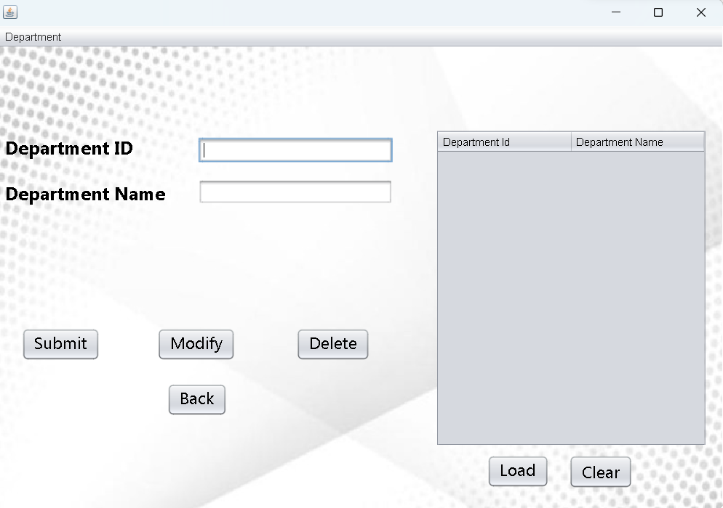

package hardware.database;

import java.sql.Connection;

import java.sql.DriverManager;

import java.sql.ResultSet;

import java.sql.Statement;

import javax.swing.JFrame;

import javax.swing.JOptionPane;

import javax.swing.table.DefaultTableModel;

public class department extends javax.swing.JFrame {

public department() {

initComponents();

}

private void initComponents() {

jLabel1 = new javax.swing.JLabel();

jLabel2 = new javax.swing.JLabel();

jTextField2 = new javax.swing.JTextField();

jButton1 = new javax.swing.JButton();

jButton2 = new javax.swing.JButton();

jButton3 = new javax.swing.JButton();

jButton4 = new javax.swing.JButton();

jButton5 = new javax.swing.JButton();

jTextField3 = new javax.swing.JTextField();

jScrollPane1 = new javax.swing.JScrollPane();

jTable1 = new javax.swing.JTable();

jButton6 = new javax.swing.JButton();

jLabel4 = new javax.swing.JLabel();

jMenuBar1 = new javax.swing.JMenuBar();

jMenu2 = new javax.swing.JMenu();

setDefaultCloseOperation(javax.swing.WindowConstants.EXIT_ON_CLOSE);

getContentPane().setLayout(new org.netbeans.lib.awtextra.AbsoluteLayout());

jLabel1.setFont(new java.awt.Font("Microsoft New Tai Lue", 1, 20)); // NOI18N

jLabel1.setText("Department ID");

getContentPane().add(jLabel1, new org.netbeans.lib.awtextra.AbsoluteConstraints(10, 100, 174, -1));

jLabel2.setFont(new java.awt.Font("Microsoft New Tai Lue", 1, 20)); // NOI18N

jLabel2.setText("Department Name");

getContentPane().add(jLabel2, new org.netbeans.lib.awtextra.AbsoluteConstraints(10, 150, 194, -1));

getContentPane().add(jTextField2, new org.netbeans.lib.awtextra.AbsoluteConstraints(222, 100, 214, -1));

jButton1.setFont(new java.awt.Font("Microsoft New Tai Lue", 0, 18)); // NOI18N

jButton1.setText("Submit");

jButton1.addActionListener(new java.awt.event.ActionListener() {

public void actionPerformed(java.awt.event.ActionEvent evt) {

jButton1ActionPerformed(evt);

}

});

getContentPane().add(jButton1, new org.netbeans.lib.awtextra.AbsoluteConstraints(28, 310, -1, -1));

jButton2.setFont(new java.awt.Font("Microsoft New Tai Lue", 0, 18)); // NOI18N

jButton2.setText("Modify");

jButton2.addActionListener(new java.awt.event.ActionListener()

public void actionPerformed(java.awt.event.ActionEvent evt) {

jButton2ActionPerformed(evt);

}

});

getContentPane().add(jButton2, new org.netbeans.lib.awtextra.AbsoluteConstraints(177, 310, -1, -1));

jButton3.setFont(new java.awt.Font("Microsoft New Tai Lue", 0, 18)); // NOI18N

jButton3.setText("Delete");

jButton3.addActionListener(new java.awt.event.ActionListener() {

public void actionPerformed(java.awt.event.ActionEvent evt) {

jButton3ActionPerformed(evt);

}

});

getContentPane().add(jButton3, new org.netbeans.lib.awtextra.AbsoluteConstraints(330, 310, -1, -1));

jButton4.setFont(new java.awt.Font("Microsoft New Tai Lue", 0, 18)); // NOI18N

jButton4.setText("Load");

jButton4.addActionListener(new java.awt.event.ActionListener() {

public void actionPerformed(java.awt.event.ActionEvent evt) {

jButton4ActionPerformed(evt);

}

});

getContentPane().add(jButton4, new org.netbeans.lib.awtextra.AbsoluteConstraints(540, 450, -1, -1));

jButton5.setFont(new java.awt.Font("Microsoft New Tai Lue", 0, 18)); // NOI18N

jButton5.setText("Back");

jButton5.addActionListener(new java.awt.event.ActionListener() {

public void actionPerformed(java.awt.event.ActionEvent evt) {

jButton5ActionPerformed(evt);

}

});

getContentPane().add(jButton5, new org.netbeans.lib.awtextra.AbsoluteConstraints(188, 371, -1, -1));

getContentPane().add(jTextField3, new org.netbeans.lib.awtextra.AbsoluteConstraints(222, 146, 214, -1));

jTable1.setModel(new javax.swing.table.DefaultTableModel(

new Object [][] {

{null, null},

{null, null},

{null, null},

{null, null},

{null, null},

{null, null},

{null, null},

{null, null},

{null, null},

{null, null},

{null, null},

{null, null},

{null, null},

{null, null},

{null, null},

{null, null},

{null, null},

{null, null},

{null, null},

{null, null}

},

new String [] {

"Department Id", "Department Name"

}

) {

Class[] types = new Class [] {

java.lang.Integer.class, java.lang.String.class

};

public Class getColumnClass(int columnIndex) {

return types [columnIndex];

}

});

jTable1.addMouseListener(new java.awt.event.MouseAdapter() {

public void mouseClicked(java.awt.event.MouseEvent evt) {

jTable1MouseClicked(evt);

}

});

jScrollPane1.setViewportView(jTable1);

getContentPane().add(jScrollPane1, new org.netbeans.lib.awtextra.AbsoluteConstraints(483, 91, 299, 350));

jButton6.setFont(new java.awt.Font("Nirmala UI", 0, 18)); // NOI18N

jButton6.setText("Clear");

jButton6.addActionListener(new java.awt.event.ActionListener() {

public void actionPerformed(java.awt.event.ActionEvent evt) {

jButton6ActionPerformed(evt);

}

});

getContentPane().add(jButton6, new org.netbeans.lib.awtextra.AbsoluteConstraints(630, 450, -1, -1));

jLabel4.setIcon(new javax.swing.ImageIcon(getClass().getResource("/hardware/database/Background.jpg"))); // NOI18N

getContentPane().add(jLabel4, new org.netbeans.lib.awtextra.AbsoluteConstraints(0, 0, 800, 510));

jMenu2.setText("Department");

jMenuBar1.add(jMenu2);

setJMenuBar(jMenuBar1);

pack();

}

private void jButton1ActionPerformed(java.awt.event.ActionEvent evt) {//GEN-FIRST:event_jButton1ActionPerformed

try

{

DriverManager.registerDriver(new oracle.jdbc.driver.OracleDriver());

// Connect to Oracle Database

Connection con = DriverManager.getConnection("jdbc:oracle:thin:@localhost:1521:XE", "vishnu", "vasavi123");

Statement statement = con.createStatement();

String query= "INSERT INTO DEPT VALUES(" + "'"+jTextField2.getText() + "',"+"'"+ jTextField3.getText()+"'" +")";

//String sqlqry="insert into customers values()"

ResultSet rs = statement.executeQuery(query);

System .out.println("Inserted ....");

rs.close();

statement.close();

con.close();

JOptionPane.showMessageDialog(new JFrame(),"INSERTED SUCCESSFULLY", "INFORMATION", JOptionPane.INFORMATION_MESSAGE);

}

catch(Exception e)

{

System.out.println(e);

JOptionPane.showMessageDialog(new JFrame(),e, "INFORMATION", JOptionPane.INFORMATION_MESSAGE);

//JOptionPane.showMessageDialog(new JFrame(),"Please fill out all fields", "Notice", JOptionPane.INFORMATION_MESSAGE);

}

}

private void jButton2ActionPerformed(java.awt.event.ActionEvent evt) {//GEN-FIRST:event_jButton2ActionPerformed

// TODO add your handling code here:

try

{

if(jTable1.getRowCount()==0)

{

JOptionPane.showMessageDialog(this, "Please load the table", "Notice", JOptionPane.INFORMATION_MESSAGE);

}

else

{

// Load Oracle JDBC Driver

int r = jTable1.getSelectedRow();

if(r<0)

{

JOptionPane.showMessageDialog(this, "Please select single Row For Update..", "Notice", JOptionPane.INFORMATION_MESSAGE);

}

else

{

// Load Oracle JDBC Driver

DriverManager.registerDriver(new oracle.jdbc.driver.OracleDriver());

// Connect to Oracle Database

Connection con = DriverManager.getConnection("jdbc:oracle:thin:@localhost:1521:XE", "vishnu", "vasavi123");

Statement statement = con.createStatement();

// Execute a SELECT query on Oracle Dummy DUAL Table. Useful for retrieving system values

// Enables us to retrieve values as if querying from a table

String query="update dept set Dept_name ='"+jTextField3.getText()+"' where dept_id= '"+jTextField2.getText()+"'";

//String sqlqry="insert into customers values()"

ResultSet rs = statement.executeQuery(query);

System .out.println("Updated ....");

JOptionPane.showMessageDialog(this,"Updated Successfully","Notice",JOptionPane.INFORMATION_MESSAGE);

rs.close();

statement.close();

con.close();

}

}

}

catch(Exception e)

{

System.out.println(e);

}

}//GEN-LAST:event_jButton2ActionPerformed

private void jButton4ActionPerformed(java.awt.event.ActionEvent evt) {//GEN-FIRST:event_jButton4ActionPerformed

try{

DriverManager.registerDriver(new oracle.jdbc.driver.OracleDriver());

// Connect to Oracle Database

Connection con = DriverManager.getConnection("jdbc:oracle:thin:@localhost:1521:XE", "vishnu", "vasavi123");

Statement statement = con.createStatement();

String query = "SELECT * FROM DEPT";

ResultSet rs = statement.executeQuery(query);

DefaultTableModel model = (DefaultTableModel)jTable1.getModel();

model.setRowCount(0);

while(rs.next())

{

model.addRow(new Object[]{ rs.getString("dept_id"),rs.getString("dept_name")});

}

rs.close();

statement.close();

con.close();

}

catch(Exception e)

{

JOptionPane.showMessageDialog(new JFrame(),e, "INFORMATION", JOptionPane.INFORMATION_MESSAGE);

}

}//GEN-LAST:event_jButton4ActionPerformed

private void jButton5ActionPerformed(java.awt.event.ActionEvent evt) {//GEN-FIRST:event_jButton5ActionPerformed

// TODO add your handling code here:

this.hide();

MAIN m =new MAIN();

m.show();

dispose();

}//GEN-LAST:event_jButton5ActionPerformed

private void jButton3ActionPerformed(java.awt.event.ActionEvent evt) {//GEN-FIRST:event_jButton3ActionPerformed

// TODO add your handling code here:

try

{

if(jTable1.getRowCount()==0)

{

JOptionPane.showMessageDialog(this, "Please load the table", "Notice", JOptionPane.INFORMATION_MESSAGE);

}

else

{

// Load Oracle JDBC Driver

int r = jTable1.getSelectedRow();

if(r<0)

{

JOptionPane.showMessageDialog(this, "Please select a row", "Notice", JOptionPane.INFORMATION_MESSAGE);

}

else

{

// Load Oracle JDBC Driver

DriverManager.registerDriver(new oracle.jdbc.driver.OracleDriver());

// Connect to Oracle Database

Connection con = DriverManager.getConnection("jdbc:oracle:thin:@localhost:1521:XE", "vishnu", "vasavi123");

Statement statement = con.createStatement();

// Execute a SELECT query on Oracle Dummy DUAL Table. Useful for retrieving system values

// Enables us to retrieve values as if querying from a table

String query="DELETE from DEPT where DEPT_id="+jTextField2.getText();

//String sqlqry="insert into customers values()"

ResultSet rs = statement.executeQuery(query);

System .out.println("Deleted ....");

JOptionPane.showMessageDialog(this,"Deleted Successfully","Notice",JOptionPane.INFORMATION_MESSAGE);

rs.close();

statement.close();

con.close();

}

}

}

catch(Exception e)

{

System.out.println(e);

}

}//GEN-LAST:event_jButton3ActionPerformed

private void jTable1MouseClicked(java.awt.event.MouseEvent evt) {//GEN-FIRST:event_jTable1MouseClicked

// TODO add your handling code here:

DefaultTableModel model = (DefaultTableModel)jTable1.getModel();

int rowindex = jTable1.getSelectedRow();

jTextField2.setText(model.getValueAt(rowindex,0).toString());

jTextField3.setText(model.getValueAt(rowindex,1).toString());

}

private void jButton6ActionPerformed(java.awt.event.ActionEvent evt) {

// TODO add your handling code here:

jTable1.setModel(new DefaultTableModel(null,new String[]{"dept_id","dept_name"}));

}

public static void main(String args[]) {

java.awt.EventQueue.invokeLater(new Runnable() {

public void run() {

new department().setVisible(true);

}

});

}

private javax.swing.JButton jButton1;

private javax.swing.JButton jButton2;

private javax.swing.JButton jButton3;

private javax.swing.JButton jButton4;

private javax.swing.JButton jButton5;

private javax.swing.JButton jButton6;

private javax.swing.JLabel jLabel1;

private javax.swing.JLabel jLabel2;

private javax.swing.JLabel jLabel4;

private javax.swing.JMenu jMenu2;

private javax.swing.JMenuBar jMenuBar1;

private javax.swing.JScrollPane jScrollPane1;

private javax.swing.JTable jTable1;

private javax.swing.JTextField jTextField2;

private javax.swing.JTextField jTextField3;

// End of variables declaration//GEN-END:variables

}

**Device Table:**

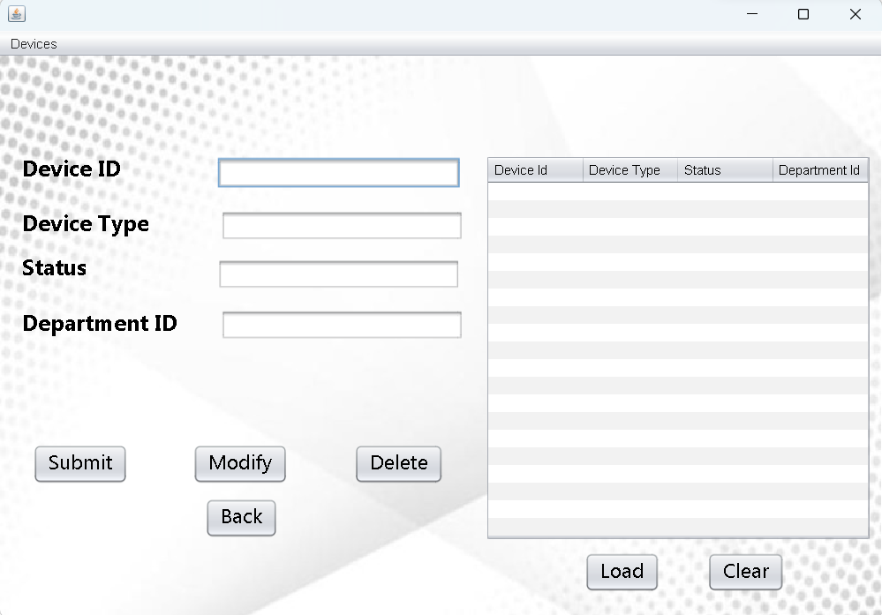

package hardware.database;

import java.sql.Connection;

import java.sql.DriverManager;

import java.sql.ResultSet;

import java.sql.Statement;

import javax.swing.JFrame;

import javax.swing.JOptionPane;

import javax.swing.table.DefaultTableModel;

public class device extends javax.swing.JFrame {

public device() {

initComponents();

}

private void initComponents() {

jLabel1 = new javax.swing.JLabel();

jLabel2 = new javax.swing.JLabel();

jLabel3 = new javax.swing.JLabel();

jLabel4 = new javax.swing.JLabel();

jTextField1 = new javax.swing.JTextField();

jTextField2 = new javax.swing.JTextField();

jTextField3 = new javax.swing.JTextField();

jTextField4 = new javax.swing.JTextField();

jButton1 = new javax.swing.JButton();

jButton2 = new javax.swing.JButton();

jButton3 = new javax.swing.JButton();

jButton5 = new javax.swing.JButton();

jScrollPane1 = new javax.swing.JScrollPane();

jTable1 = new javax.swing.JTable();

jButton6 = new javax.swing.JButton();

jButton7 = new javax.swing.JButton();

jLabel5 = new javax.swing.JLabel();

jMenuBar1 = new javax.swing.JMenuBar();

jMenu2 = new javax.swing.JMenu();

setDefaultCloseOperation(javax.swing.WindowConstants.EXIT_ON_CLOSE);

getContentPane().setLayout(new org.netbeans.lib.awtextra.AbsoluteLayout());

jLabel1.setFont(new java.awt.Font("Microsoft New Tai Lue", 1, 20)); // NOI18N

jLabel1.setText("Device ID");

getContentPane().add(jLabel1, new org.netbeans.lib.awtextra.AbsoluteConstraints(20, 90, 161, -1));

jLabel2.setFont(new java.awt.Font("Microsoft New Tai Lue", 1, 20)); // NOI18N

jLabel2.setText("Device Type");

getContentPane().add(jLabel2, new org.netbeans.lib.awtextra.AbsoluteConstraints(20, 140, 161, -1));

jLabel3.setFont(new java.awt.Font("Microsoft New Tai Lue", 1, 20)); // NOI18N

jLabel3.setText("Status");

getContentPane().add(jLabel3, new org.netbeans.lib.awtextra.AbsoluteConstraints(20, 180, 161, -1));

jLabel4.setFont(new java.awt.Font("Microsoft New Tai Lue", 1, 20)); // NOI18N

jLabel4.setText("Department ID");

getContentPane().add(jLabel4, new org.netbeans.lib.awtextra.AbsoluteConstraints(20, 230, 161, -1));

getContentPane().add(jTextField1, new org.netbeans.lib.awtextra.AbsoluteConstraints(197, 92, 220, -1));

getContentPane().add(jTextField2, new org.netbeans.lib.awtextra.AbsoluteConstraints(197, 229, 220, -1));

getContentPane().add(jTextField3, new org.netbeans.lib.awtextra.AbsoluteConstraints(197, 184, 220, -1));

getContentPane().add(jTextField4, new org.netbeans.lib.awtextra.AbsoluteConstraints(197, 138, 220, -1));

jButton1.setFont(new java.awt.Font("Microsoft New Tai Lue", 0, 18)); // NOI18N

jButton1.setText("Submit");

jButton1.addActionListener(new java.awt.event.ActionListener() {

public void actionPerformed(java.awt.event.ActionEvent evt) {

jButton1ActionPerformed(evt);

}

});

getContentPane().add(jButton1, new org.netbeans.lib.awtextra.AbsoluteConstraints(30, 352, -1, -1));

jButton2.setFont(new java.awt.Font("Microsoft New Tai Lue", 0, 18)); // NOI18N

jButton2.setText("Modify");

jButton2.addActionListener(new java.awt.event.ActionListener() {

public void actionPerformed(java.awt.event.ActionEvent evt) {

jButton2ActionPerformed(evt);

}

});

getContentPane().add(jButton2, new org.netbeans.lib.awtextra.AbsoluteConstraints(175, 352, -1, -1));

jButton3.setFont(new java.awt.Font("Microsoft New Tai Lue", 0, 18)); // NOI18N

jButton3.setText("Delete");

jButton3.addActionListener(new java.awt.event.ActionListener() {

public void actionPerformed(java.awt.event.ActionEvent evt) {

jButton3ActionPerformed(evt);

}

});

getContentPane().add(jButton3, new org.netbeans.lib.awtextra.AbsoluteConstraints(321, 352, -1, -1));

jButton5.setFont(new java.awt.Font("Microsoft New Tai Lue", 0, 18)); // NOI18N

jButton5.setText("Back");

jButton5.addActionListener(new java.awt.event.ActionListener() {

public void actionPerformed(java.awt.event.ActionEvent evt) {

jButton5ActionPerformed(evt);

}

});

getContentPane().add(jButton5, new org.netbeans.lib.awtextra.AbsoluteConstraints(186, 401, -1, -1));

jTable1.setModel(new javax.swing.table.DefaultTableModel(

new Object [][] {

{null, null, null, null},

{null, null, null, null},

{null, null, null, null},

{null, null, null, null},

{null, null, null, null},

{null, null, null, null},

{null, null, null, null},

{null, null, null, null},

{null, null, null, null},

{null, null, null, null},

{null, null, null, null},

{null, null, null, null},

{null, null, null, null},

{null, null, null, null},

{null, null, null, null},

{null, null, null, null},

{null, null, null, null},

{null, null, null, null},

{null, null, null, null},

{null, null, null, null}

},

new String [] {

"Device Id", "Device Type", "Status", "Department Id"

}

) {

Class[] types = new Class [] {

java.lang.Integer.class, java.lang.String.class, java.lang.String.class, java.lang.Integer.class

};

public Class getColumnClass(int columnIndex) {

return types [columnIndex];

}

});

jTable1.addMouseListener(new java.awt.event.MouseAdapter() {

public void mouseClicked(java.awt.event.MouseEvent evt) {

jTable1MouseClicked(evt);

}

});

jScrollPane1.setViewportView(jTable1);

getContentPane().add(jScrollPane1, new org.netbeans.lib.awtextra.AbsoluteConstraints(440, 90, 350, 350));

jButton6.setFont(new java.awt.Font("Microsoft New Tai Lue", 0, 18)); // NOI18N

jButton6.setText("Clear");

jButton6.addActionListener(new java.awt.event.ActionListener() {

public void actionPerformed(java.awt.event.ActionEvent evt) {

jButton6ActionPerformed(evt);

}

});

getContentPane().add(jButton6, new org.netbeans.lib.awtextra.AbsoluteConstraints(641, 450, -1, -1));

jButton7.setFont(new java.awt.Font("Microsoft New Tai Lue", 0, 18)); // NOI18N

jButton7.setText("Load");

jButton7.addActionListener(new java.awt.event.ActionListener() {

public void actionPerformed(java.awt.event.ActionEvent evt) {

jButton7ActionPerformed(evt);

}

});

getContentPane().add(jButton7, new org.netbeans.lib.awtextra.AbsoluteConstraints(530, 450, -1, -1));

jLabel5.setIcon(new javax.swing.ImageIcon(getClass().getResource("/hardware/database/Background.jpg"))); // NOI18N

getContentPane().add(jLabel5, new org.netbeans.lib.awtextra.AbsoluteConstraints(0, 0, 800, 510));

jMenu2.setText("Devices");

jMenuBar1.add(jMenu2);

setJMenuBar(jMenuBar1);

pack();

}

private void jButton2ActionPerformed(java.awt.event.ActionEvent evt) {//GEN-FIRST:event_jButton2ActionPerformed

// TODO add your handling code here:

try

{

if(jTable1.getRowCount()==0)

{

JOptionPane.showMessageDialog(this, "Please load the table", "Notice", JOptionPane.INFORMATION_MESSAGE);

}

else

{

// Load Oracle JDBC Driver

int r = jTable1.getSelectedRow();

if(r<0)

{

JOptionPane.showMessageDialog(this, "Please select a row", "Notice", JOptionPane.INFORMATION_MESSAGE);

}

else

{

// Load Oracle JDBC Driver

DriverManager.registerDriver(new oracle.jdbc.driver.OracleDriver());

// Connect to Oracle Database

Connection con = DriverManager.getConnection("jdbc:oracle:thin:@localhost:1521:XE", "vishnu", "vasavi123");

Statement statement = con.createStatement();

// Execute a SELECT query on Oracle Dummy DUAL Table. Useful for retrieving system values

// Enables us to retrieve values as if querying from a table

String query="update devices set device_type ='"+jTextField2.getText()+"' where device_id= '"+jTextField1.getText()+"'";

//String sqlqry="insert into customers values()"

ResultSet rs = statement.executeQuery(query);

System .out.println("Updated ....");

JOptionPane.showMessageDialog(this,"Updated Successfully","Notice",JOptionPane.INFORMATION_MESSAGE);

rs.close();

statement.close();

con.close();

}

}

}

catch(Exception e)

{

System.out.println(e);

}

}//GEN-LAST:event_jButton2ActionPerformed

private void jButton1ActionPerformed(java.awt.event.ActionEvent evt) {//GEN-FIRST:event_jButton1ActionPerformed

// TODO add your handling code here:

try

{

// Load Oracle JDBC Driver

DriverManager.registerDriver(new oracle.jdbc.driver.OracleDriver());

// Connect to Oracle Database

Connection con = DriverManager.getConnection("jdbc:oracle:thin:@localhost:1521:XE", "vishnu", "vasavi123");

Statement statement = con.createStatement();

// Execute a SELECT query on Oracle Dummy DUAL Table. Useful for retrieving system values

// Enables us to retrieve values as if querying from a table

String query= "INSERT INTO DEVICES VALUES(" + jTextField1.getText() + ","+ "'" +jTextField2.getText() +"',"+ "'"+jTextField3.getText() +"',+"+"'"+ jTextField4.getText()+"'" +")";

//String sqlqry="insert into customers values()"

ResultSet rs = statement.executeQuery(query);

System .out.println("Inserted ....");

JOptionPane.showMessageDialog(new JFrame(),"INSERTED SUCCESSFULLY", "INFORMATION", JOptionPane.INFORMATION_MESSAGE);

rs.close();

statement.close();

con.close();

}

catch(Exception e)

{

System.out.println(e);

JOptionPane.showMessageDialog(new JFrame(),e, "INFORMATION", JOptionPane.INFORMATION_MESSAGE);

}

}

private void jButton3ActionPerformed(java.awt.event.ActionEvent evt) {//GEN-FIRST:event_jButton3ActionPerformed

// TODO add your handling code here:

try

{

if(jTable1.getRowCount()==0)

{

JOptionPane.showMessageDialog(this, "Please load the table", "Notice", JOptionPane.INFORMATION_MESSAGE);

}

else

{

// Load Oracle JDBC Driver

int r = jTable1.getSelectedRow();

if(r<0)

{

JOptionPane.showMessageDialog(this, "Please select a row", "Notice", JOptionPane.INFORMATION_MESSAGE);

}

else

{

// Load Oracle JDBC Driver

DriverManager.registerDriver(new oracle.jdbc.driver.OracleDriver());

// Connect to Oracle Database

Connection con = DriverManager.getConnection("jdbc:oracle:thin:@localhost:1521:XE", "vishnu", "vasavi123");

Statement statement = con.createStatement();

String query="DELETE from devices where device_id="+jTextField1.getText();

//String sqlqry="insert into customers values()"

ResultSet rs = statement.executeQuery(query);

System .out.println("Deleted ....");

JOptionPane.showMessageDialog(this,"Deleted Successfully","Notice",JOptionPane.INFORMATION_MESSAGE);

rs.close();

statement.close();

con.close();

}

}

}

catch(Exception e)

{

System.out.println(e);

}

}

private void jButton5ActionPerformed(java.awt.event.ActionEvent evt) {

this.hide();

MAIN m =new MAIN();

m.show();

dispose();

}

private void jTable1MouseClicked(java.awt.event.MouseEvent evt) {//GEN-FIRST:event_jTable1MouseClicked

DefaultTableModel model = (DefaultTableModel)jTable1.getModel();

int rowindex = jTable1.getSelectedRow();

jTextField1.setText(model.getValueAt(rowindex,0).toString());

jTextField4.setText(model.getValueAt(rowindex,1).toString());

jTextField3.setText(model.getValueAt(rowindex,2).toString());

jTextField2.setText(model.getValueAt(rowindex,3).toString());

}

private void jButton6ActionPerformed(java.awt.event.ActionEvent evt) {//GEN-FIRST:event_jButton6ActionPerformed

jTable1.setModel(new DefaultTableModel(null,new String[]{"device_id","device_type","status","dept_id",}));

}

private void jButton7ActionPerformed(java.awt.event.ActionEvent evt) {//GEN-FIRST:event_jButton7ActionPerformed

try{

DriverManager.registerDriver(new oracle.jdbc.driver.OracleDriver());

// Connect to Oracle Database

Connection con = DriverManager.getConnection("jdbc:oracle:thin:@localhost:1521:XE", "vishnu", "vasavi123");

Statement statement = con.createStatement();

String query = "SELECT * FROM DEVICES";

ResultSet rs = statement.executeQuery(query);

DefaultTableModel model = (DefaultTableModel)jTable1.getModel();

model.setRowCount(0);

while(rs.next())

{

model.addRow(new Object[]{rs.getString("device_id"),rs.getString("device_type"), rs.getString("status"),rs.getString("dept_id")});

}

rs.close();

statement.close();

con.close();

}

catch(Exception e)

{

JOptionPane.showMessageDialog(new JFrame(),e, "INFORMATION", JOptionPane.INFORMATION_MESSAGE);

}

}

public static void main(String args[]) {

/* Create and display the form */

java.awt.EventQueue.invokeLater(new Runnable() {

public void run() {

new device().setVisible(true);

}

});

}

// Variables declaration - do not modify//GEN-BEGIN:variables

private javax.swing.JButton jButton1;

private javax.swing.JButton jButton2;

private javax.swing.JButton jButton3;

private javax.swing.JButton jButton5;

private javax.swing.JButton jButton6;

private javax.swing.JButton jButton7;

private javax.swing.JLabel jLabel1;

private javax.swing.JLabel jLabel2;

private javax.swing.JLabel jLabel3;

private javax.swing.JLabel jLabel4;

private javax.swing.JLabel jLabel5;

private javax.swing.JMenu jMenu2;

private javax.swing.JMenuBar jMenuBar1;

private javax.swing.JScrollPane jScrollPane1;

private javax.swing.JTable jTable1;

private javax.swing.JTextField jTextField1;

private javax.swing.JTextField jTextField2;

private javax.swing.JTextField jTextField3;

private javax.swing.JTextField jTextField4;

// End of variables declaration//GEN-END:variables

}

**Analysis Table:**

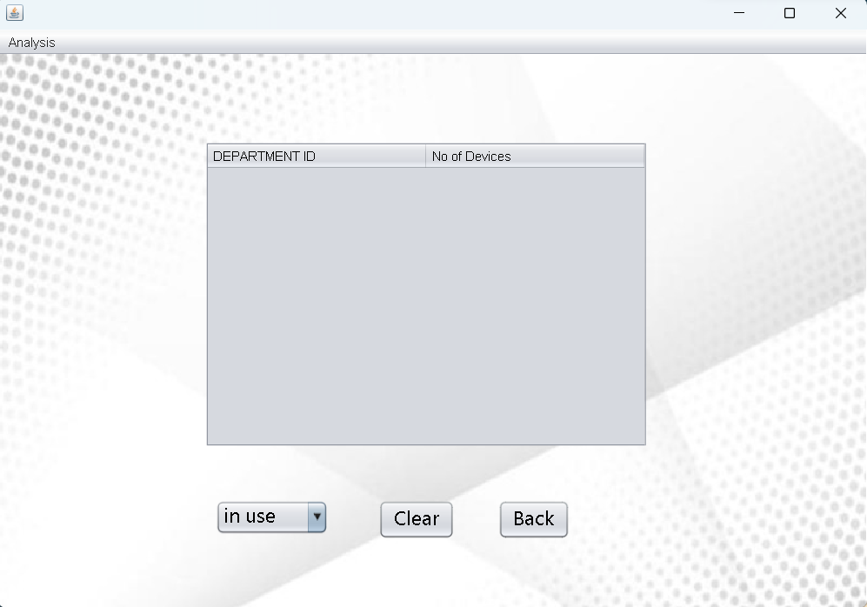

package hardware.database;

import java.sql.*;

import java.sql.DriverManager;

import java.sql.Statement;

import javax.swing.table.DefaultTableModel;

public class analysis extends javax.swing.JFrame {

public analysis() {

initComponents();

}

private void initComponents() {

jScrollPane1 = new javax.swing.JScrollPane();

jTable1 = new javax.swing.JTable();

jComboBox1 = new javax.swing.JComboBox<>();

jButton1 = new javax.swing.JButton();

jButton4 = new javax.swing.JButton();

jLabel1 = new javax.swing.JLabel();

jMenuBar1 = new javax.swing.JMenuBar();

jMenu1 = new javax.swing.JMenu();

setDefaultCloseOperation(javax.swing.WindowConstants.EXIT_ON_CLOSE);

getContentPane().setLayout(new org.netbeans.lib.awtextra.AbsoluteLayout());

jTable1.setModel(new javax.swing.table.DefaultTableModel(

new Object [][] {

},

new String [] {

"DEPARTMENT ID", "No of Devices"

}

) {

Class[] types = new Class [] {

java.lang.Integer.class, java.lang.Integer.class

};

boolean[] canEdit = new boolean [] {

false, false

};

public Class getColumnClass(int columnIndex) {

return types [columnIndex];

}

public boolean isCellEditable(int rowIndex, int columnIndex) {

return canEdit [columnIndex];

}

});

jScrollPane1.setViewportView(jTable1);

if (jTable1.getColumnModel().getColumnCount() > 0) {

jTable1.getColumnModel().getColumn(0).setResizable(false);

jTable1.getColumnModel().getColumn(1).setResizable(false);

}

getContentPane().add(jScrollPane1, new org.netbeans.lib.awtextra.AbsoluteConstraints(190, 80, 408, 282));

jComboBox1.setFont(new java.awt.Font("Microsoft New Tai Lue", 0, 18)); // NOI18N

jComboBox1.setModel(new javax.swing.DefaultComboBoxModel<>(new String[] { "in use", "not in use" }));

jComboBox1.addActionListener(new java.awt.event.ActionListener() {

public void actionPerformed(java.awt.event.ActionEvent evt) {

jComboBox1ActionPerformed(evt);

}

});

getContentPane().add(jComboBox1, new org.netbeans.lib.awtextra.AbsoluteConstraints(200, 410, 104, 32));

jButton1.setFont(new java.awt.Font("Microsoft New Tai Lue", 0, 18)); // NOI18N

jButton1.setText("Back");

jButton1.addActionListener(new java.awt.event.ActionListener() {

public void actionPerformed(java.awt.event.ActionEvent evt) {

jButton1ActionPerformed(evt);

}

});

getContentPane().add(jButton1, new org.netbeans.lib.awtextra.AbsoluteConstraints(460, 410, -1, -1));

jButton4.setFont(new java.awt.Font("Microsoft New Tai Lue", 0, 18)); // NOI18N

jButton4.setText("Clear");

jButton4.addActionListener(new java.awt.event.ActionListener() {

public void actionPerformed(java.awt.event.ActionEvent evt) {

jButton4ActionPerformed(evt);

}

});

getContentPane().add(jButton4, new org.netbeans.lib.awtextra.AbsoluteConstraints(350, 410, -1, -1));

jLabel1.setIcon(new javax.swing.ImageIcon(getClass().getResource("/hardware/database/Background.jpg"))); // NOI18N

getContentPane().add(jLabel1, new org.netbeans.lib.awtextra.AbsoluteConstraints(0, 0, 800, 510));

jMenu1.setText("Analysis");

jMenuBar1.add(jMenu1);

setJMenuBar(jMenuBar1);

pack();

}

private void jButton1ActionPerformed(java.awt.event.ActionEvent evt) {

this.hide();

MAIN m =new MAIN();

m.show();

dispose();

}

private void jComboBox1ActionPerformed(java.awt.event.ActionEvent evt) {

try{

DriverManager.registerDriver(new oracle.jdbc.driver.OracleDriver());

Connection con = DriverManager.getConnection("jdbc:oracle:thin:@localhost:1521:XE", "vishnu", "vasavi123");

Statement stmt = con.createStatement();

String sqlqry;

String selectedvalue1 =jComboBox1.getSelectedItem().toString();

sqlqry= "select dept_id, count(device_type) from devices where status='"+selectedvalue1+"'group by dept_id";

ResultSet Rs = stmt.executeQuery(sqlqry);

DefaultTableModel model = (DefaultTableModel)jTable1.getModel();

while(Rs.next())

{

model.addRow(new Object[]{Rs.getString("dept_id"), Rs.getInt("count(device_type)")});

}

System.out.println("Values retrived");

con.close();

}catch(Exception e){

System.out.println(e);

}

}

private void jButton4ActionPerformed(java.awt.event.ActionEvent evt) {//GEN-FIRST:event_jButton4ActionPerformed

jTable1.setModel(new DefaultTableModel(null,new String[]{"dept_id","no of devices"}));

}

public static void main(String args[]) {

java.awt.EventQueue.invokeLater(new Runnable() {

public void run() {

new analysis().setVisible(true);

}

});

}

private javax.swing.JButton jButton1;

private javax.swing.JButton jButton4;

private javax.swing.JComboBox<String> jComboBox1;

private javax.swing.JLabel jLabel1;

private javax.swing.JMenu jMenu1;

private javax.swing.JMenuBar jMenuBar1;

private javax.swing.JScrollPane jScrollPane1;

private javax.swing.JTable jTable1;

}

**GitHub Links and Folder Structure**

**Link:** [**https://github.com/VishnuVardhan008/College-Network-Hardware-Database.git**](https://github.com/VishnuVardhan008/College-Network-Hardware-Database.git)

**Folder Structure:**

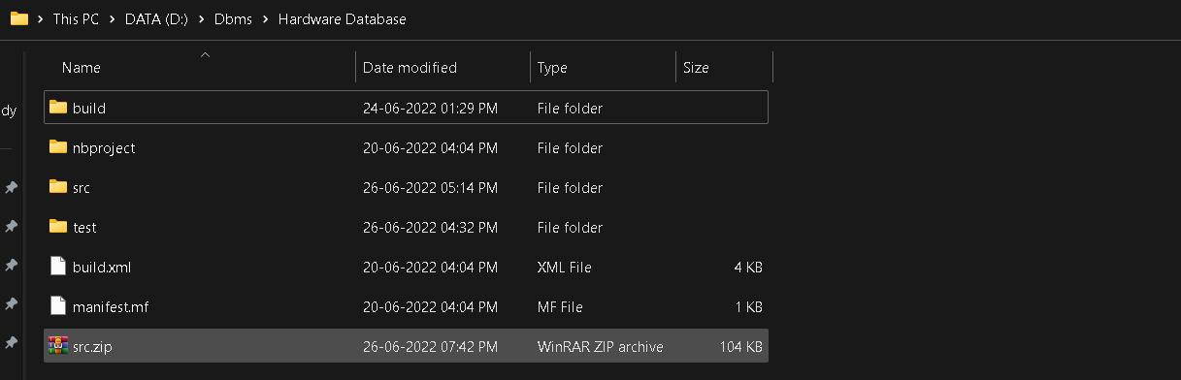

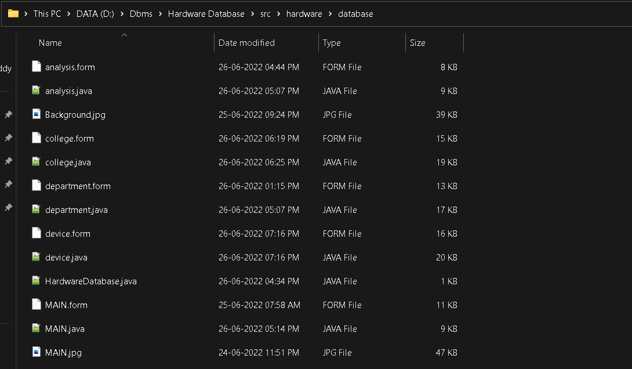

# TESTING

###### **Home page:**

In the home page user can find 4 buttons in which user can enter into the associated form .





###### **Insert College Table :**

If College_ID(primary key) is not repeated then it get inserted successfully .

If College_ID is repeated(primary key can’t have multiple values) then it show error message.

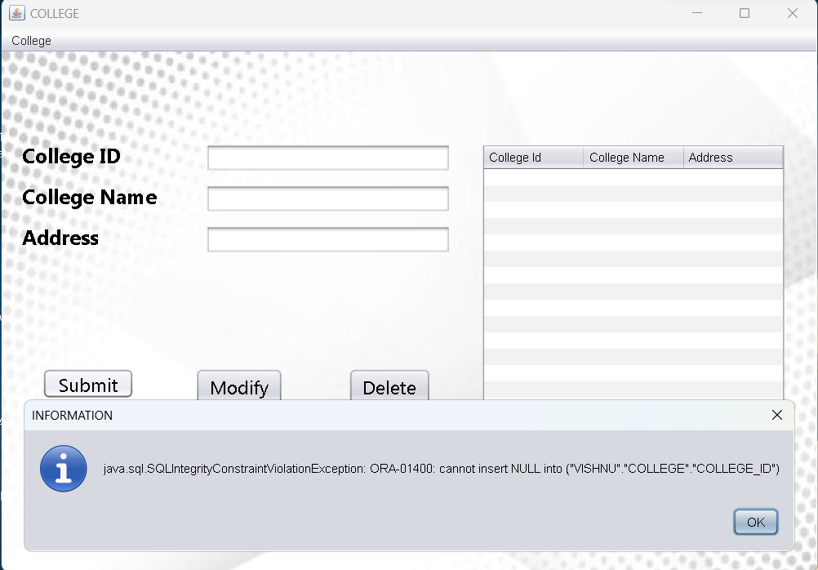

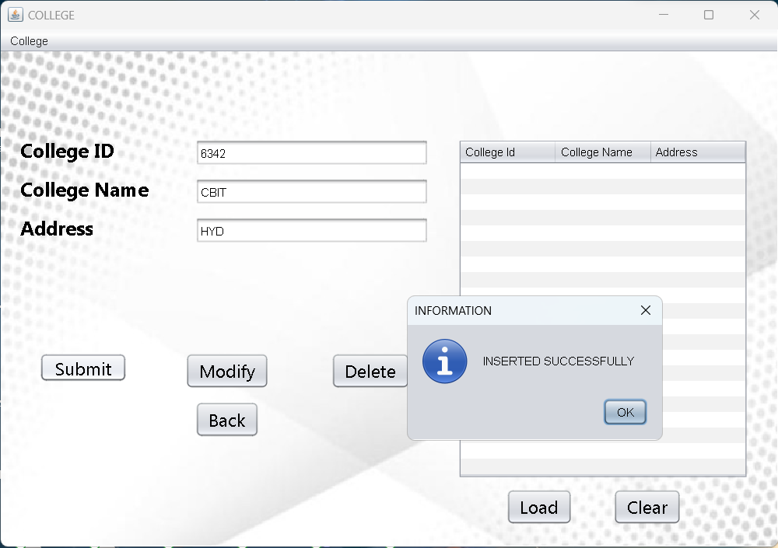

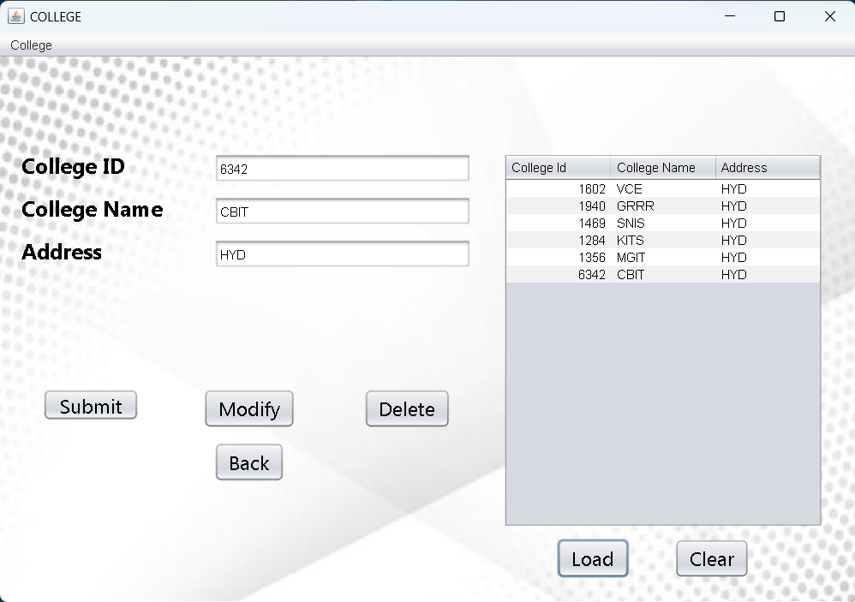

**Modify College Table:**

To modify the data first click on load button and select a row which is to be modified and modify the data in that text field . If we type in text field and enter data directly then it will display a notice box.

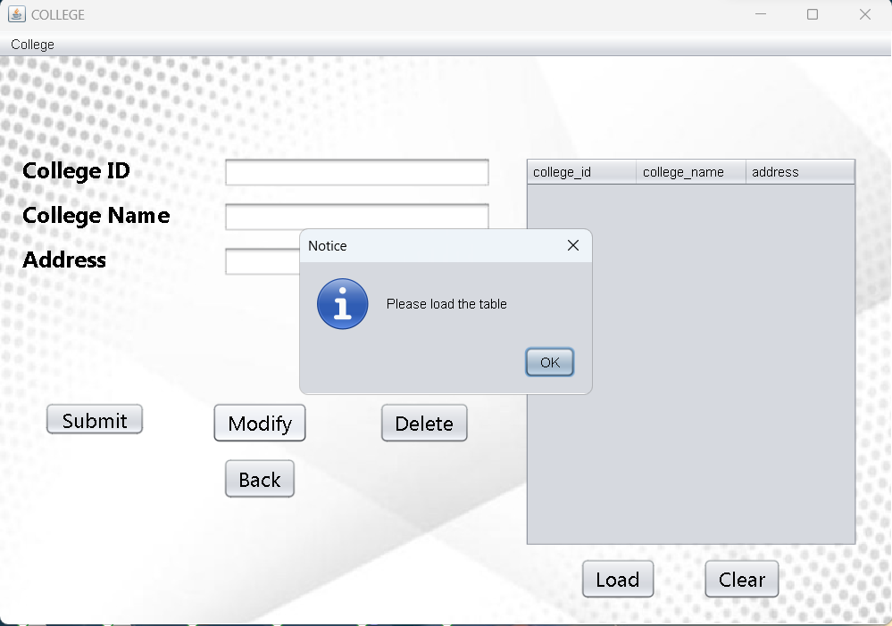

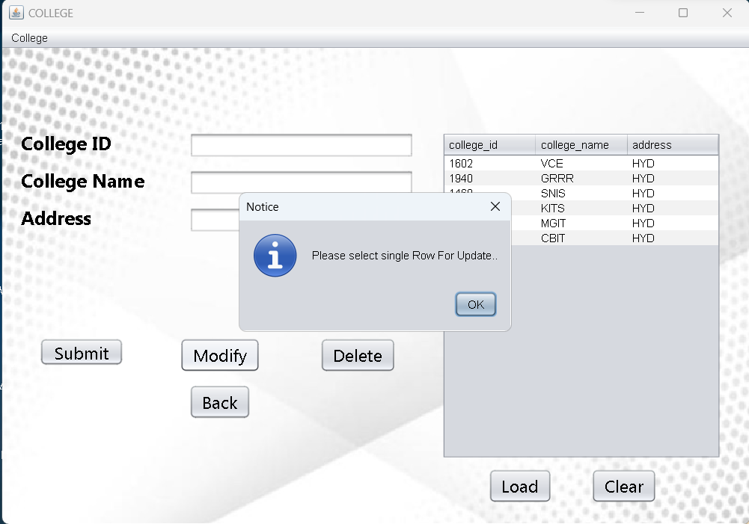

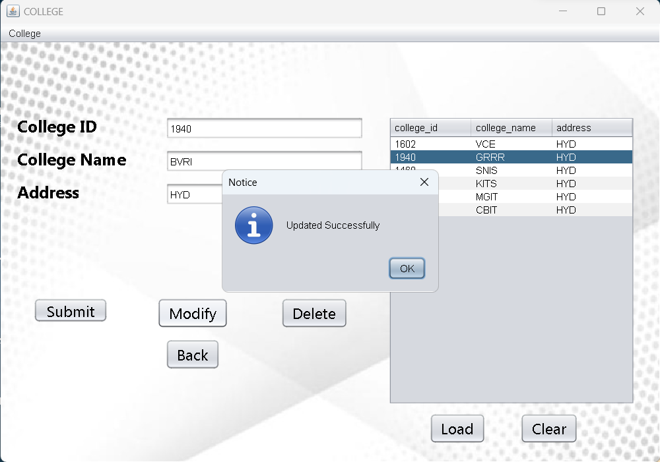

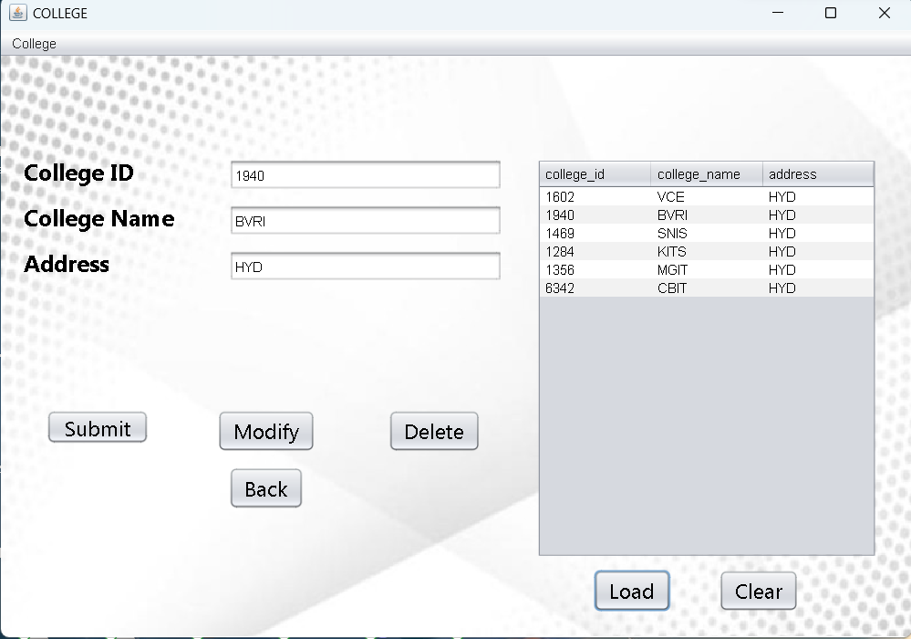

**Delete College Table:**

To delete the data first click on load button and select a row which is to be deleted. If we type in text field and enter data to delete directly then it will display a notice box.

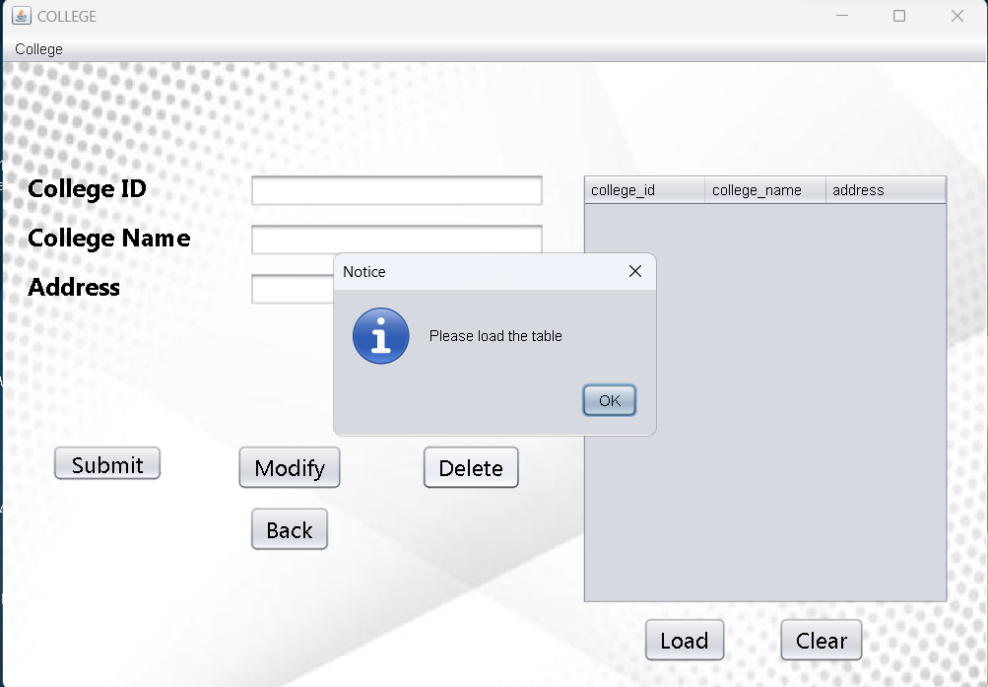

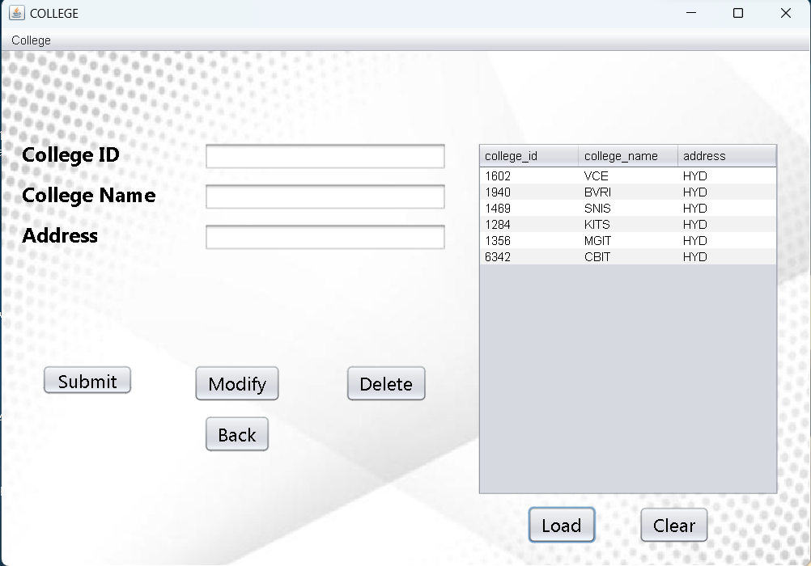

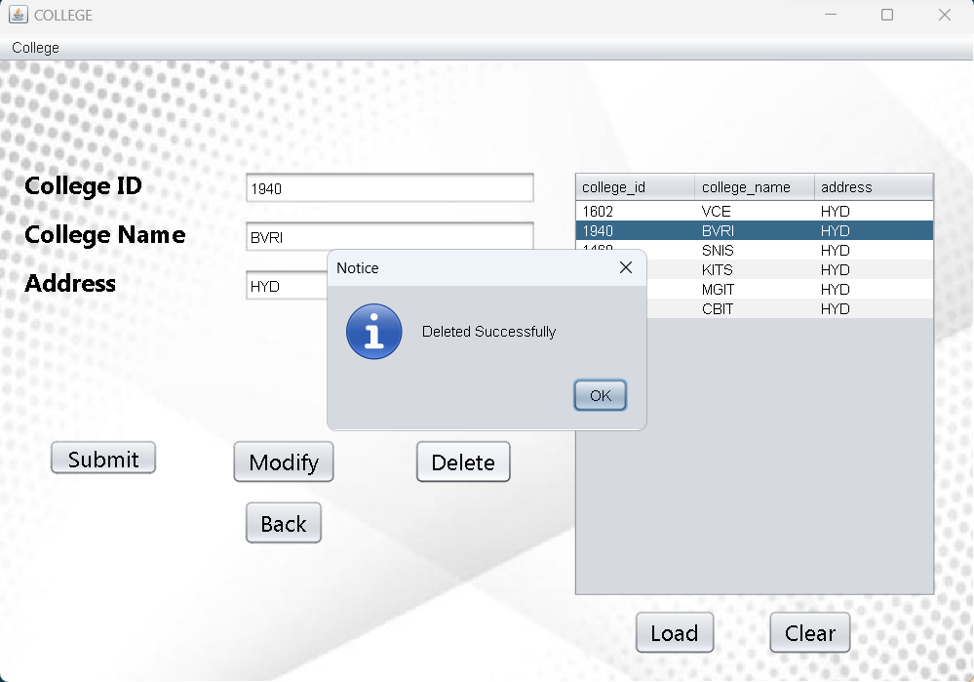

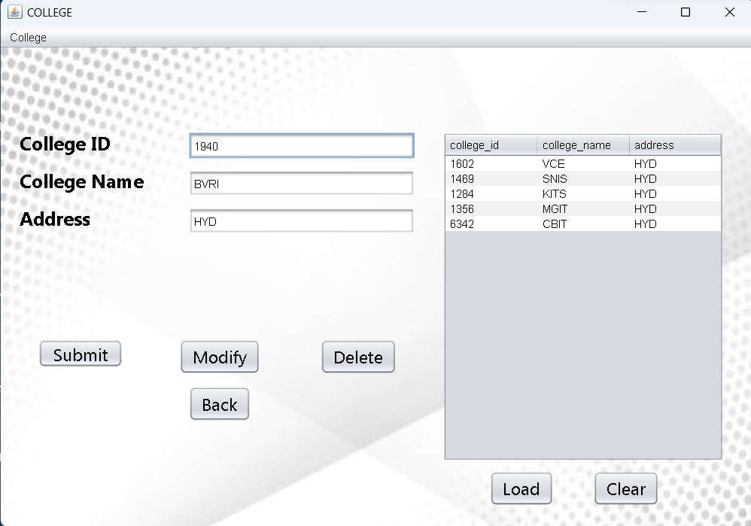

**Insert Department Table:**

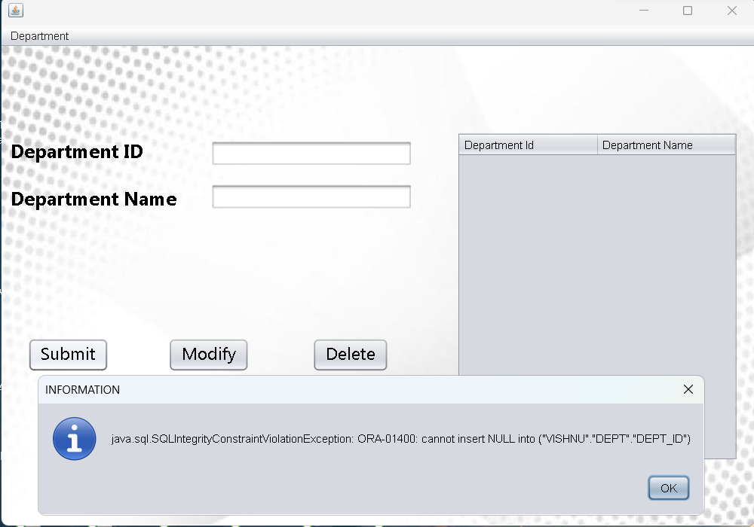

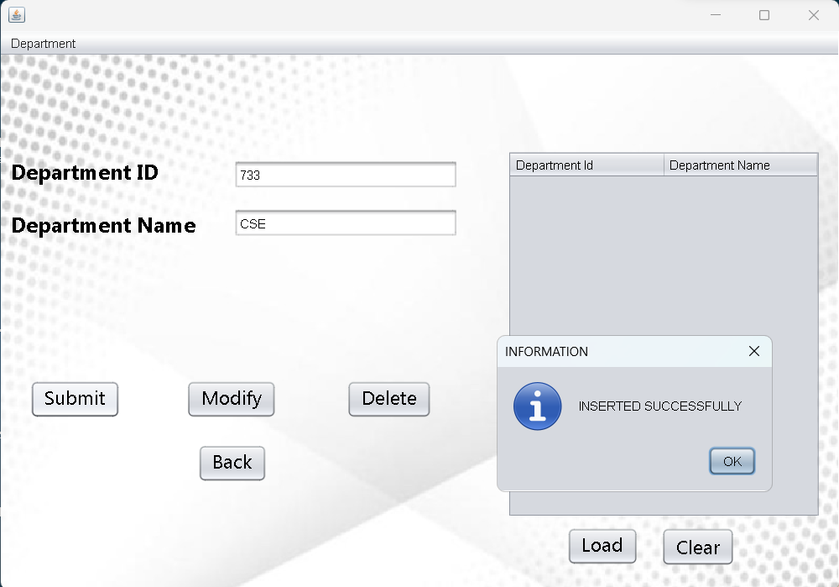

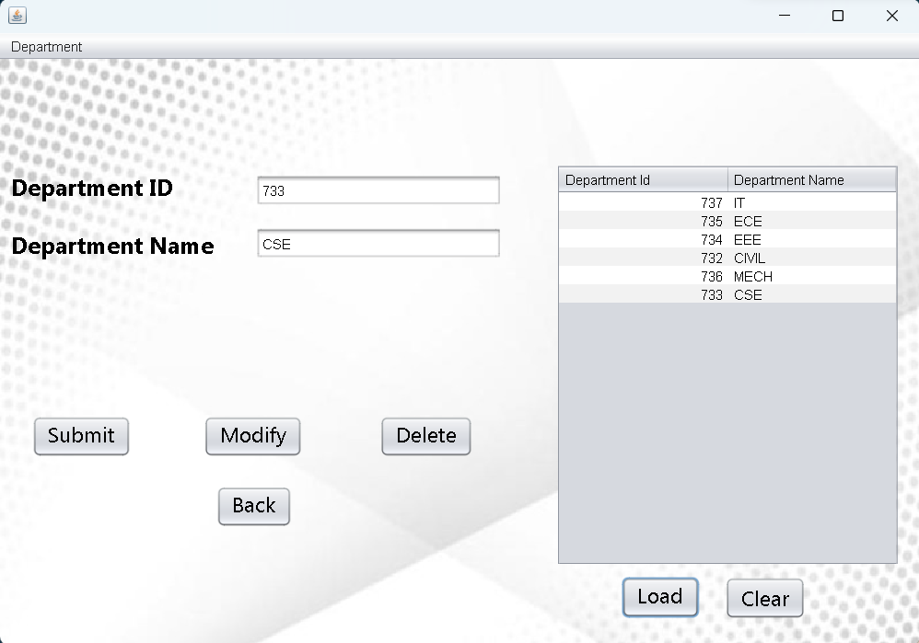

**Modify Department Table:**

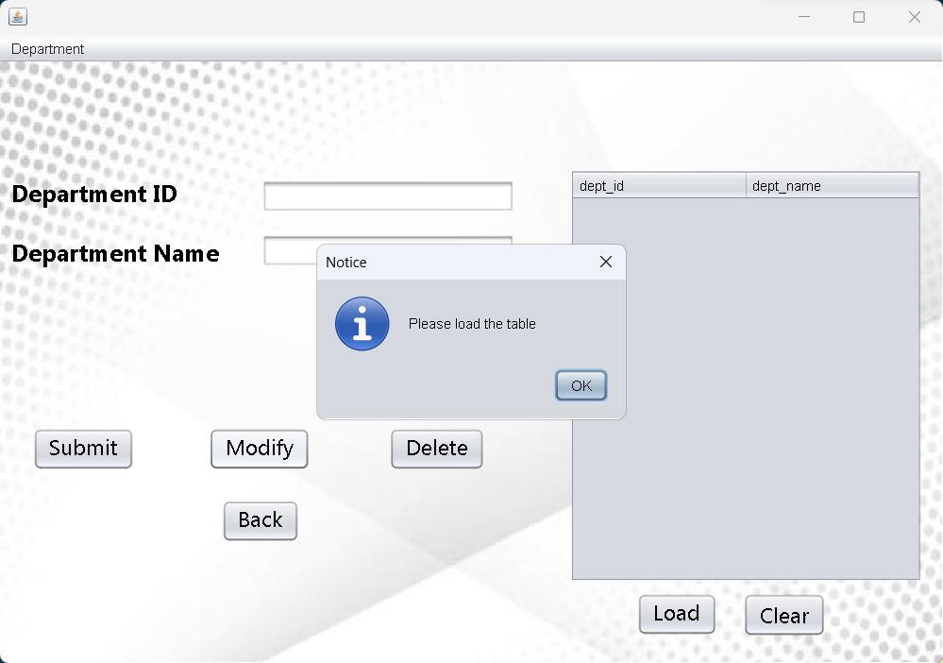

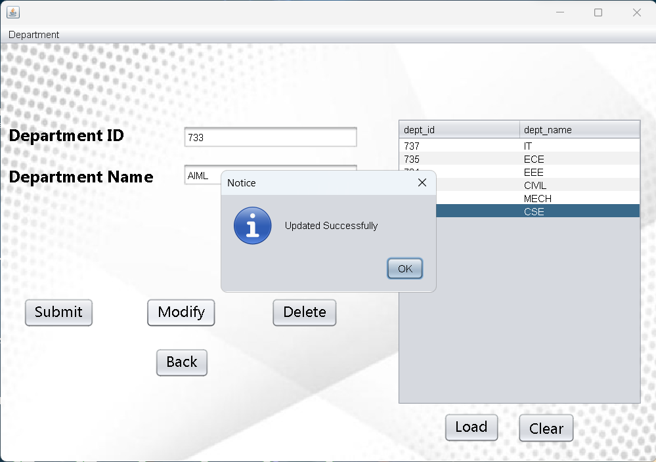

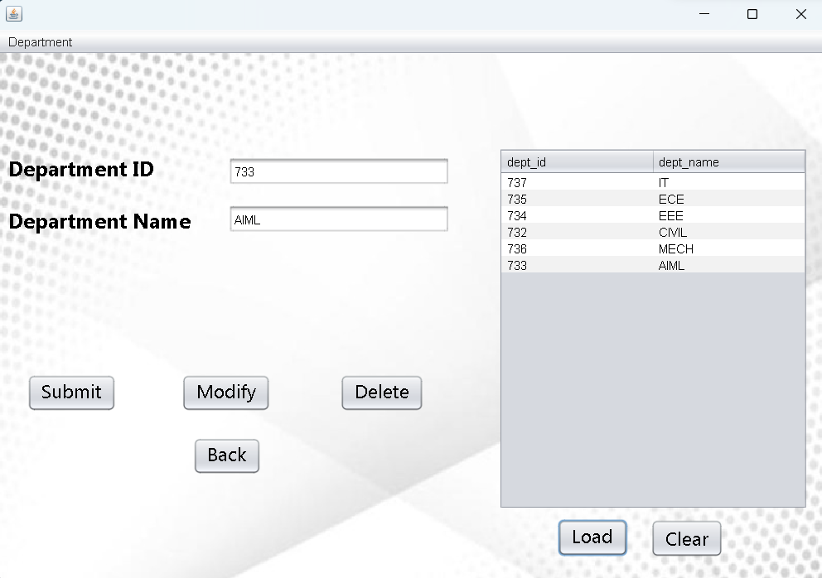

**Delete Department Table:**

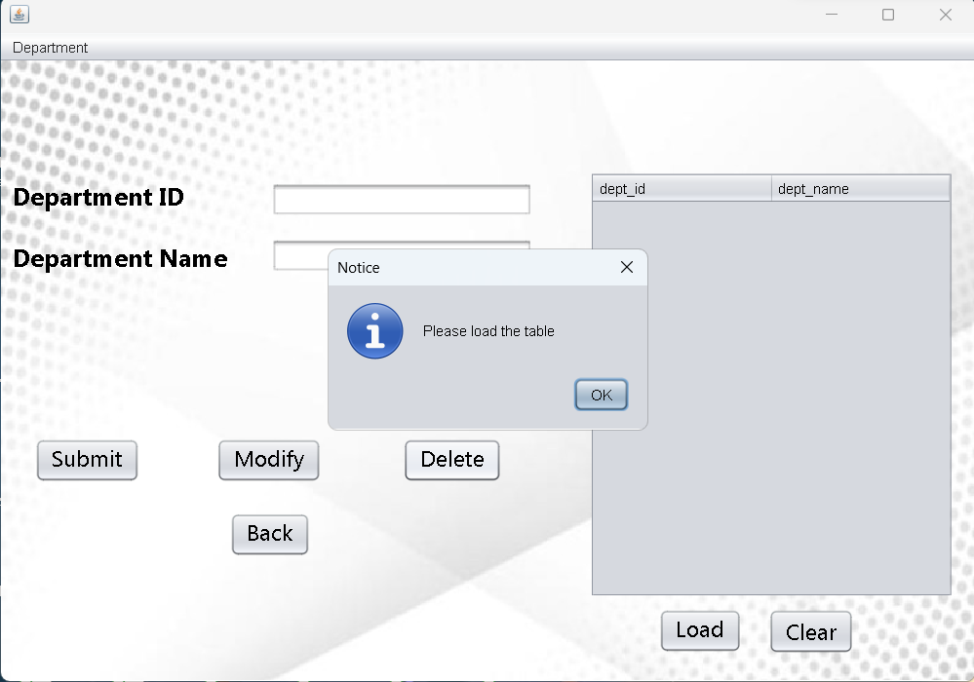

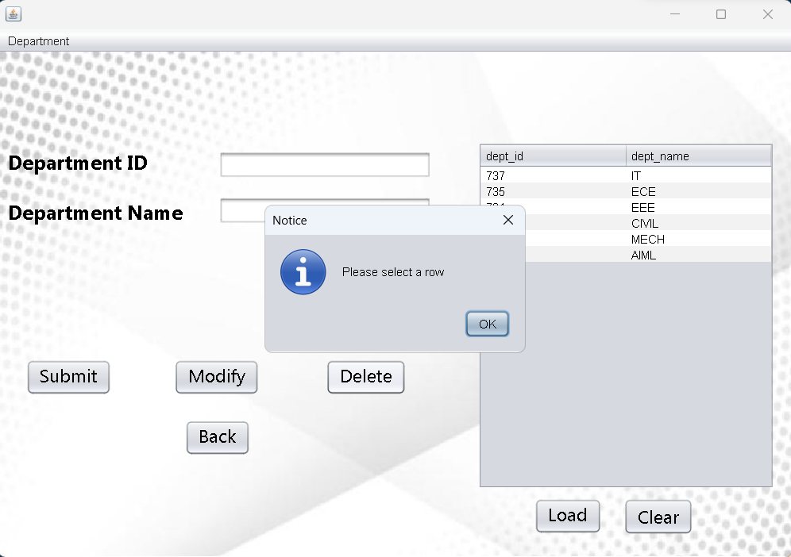

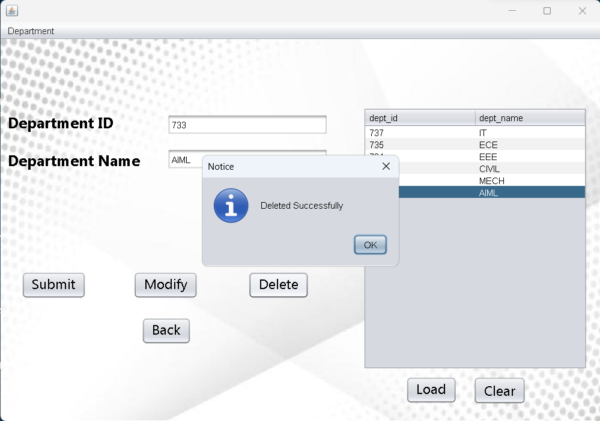

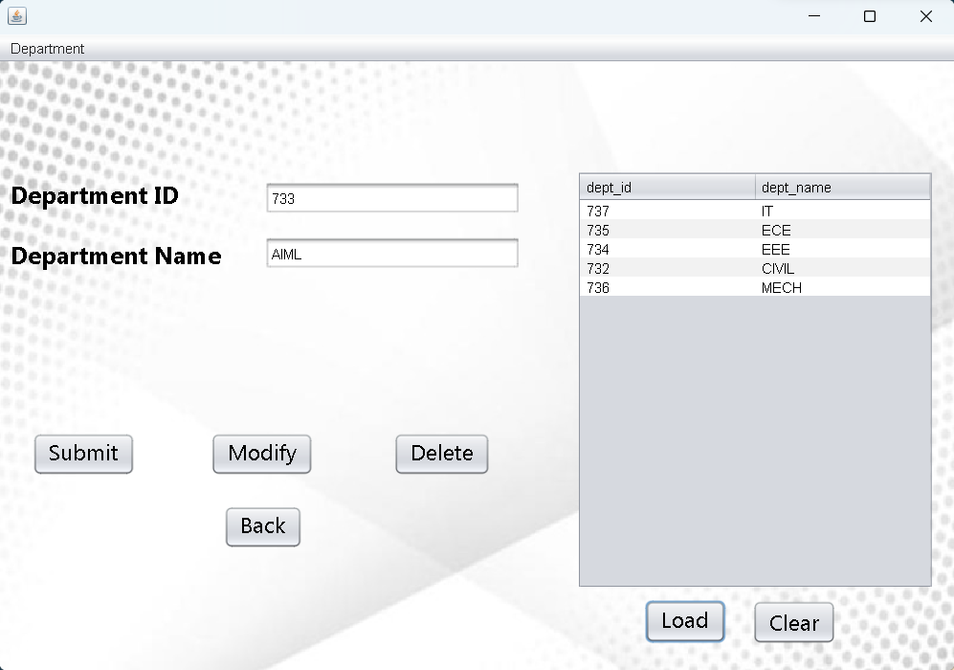

**Insert Device Table:**

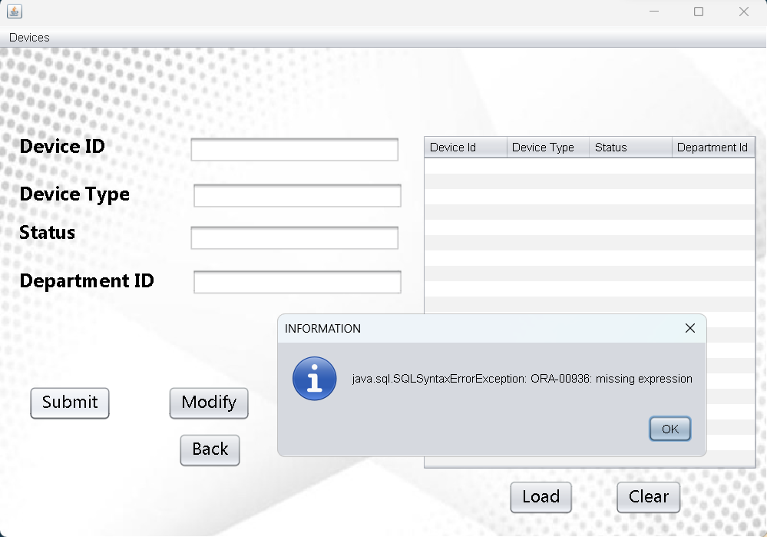

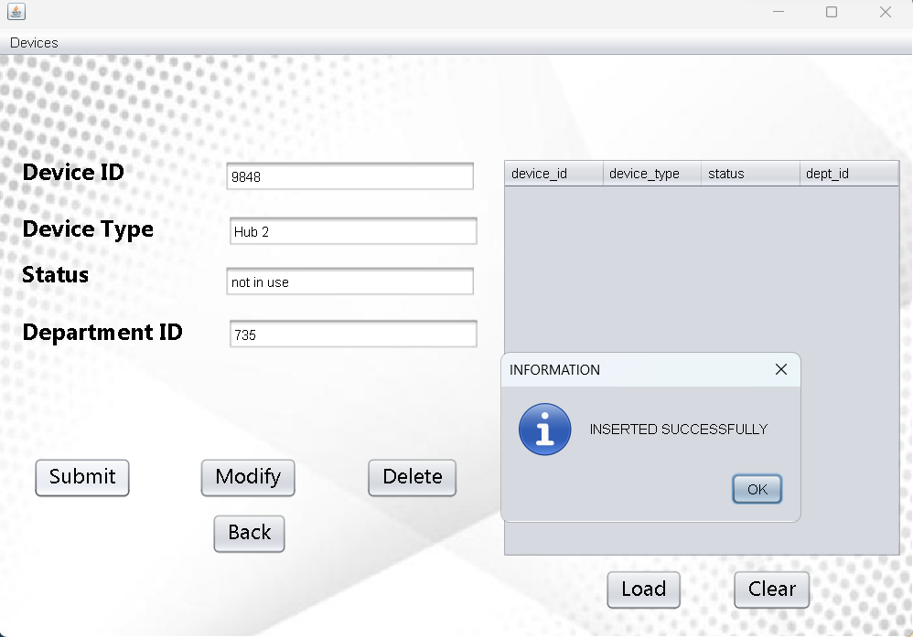

**Modify Device Table:**

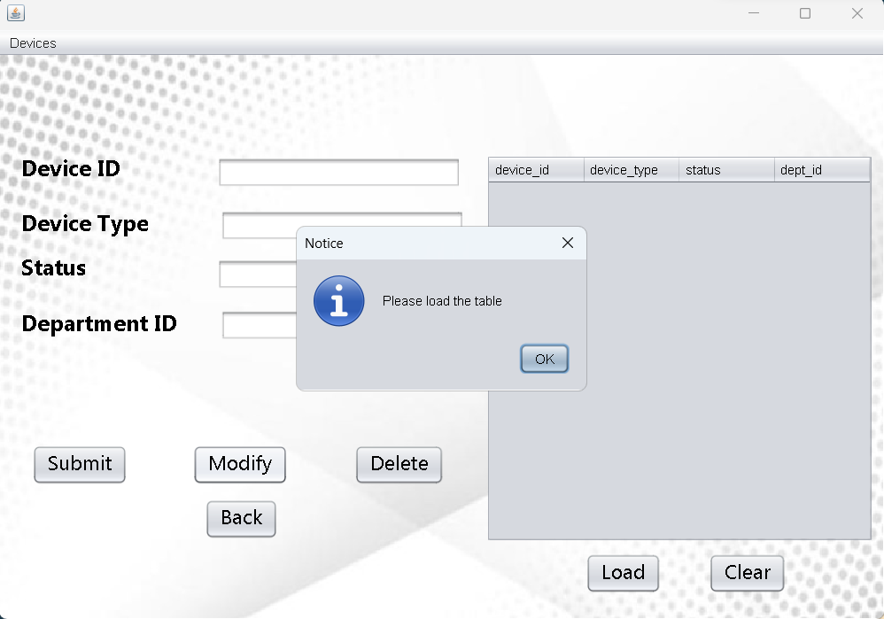

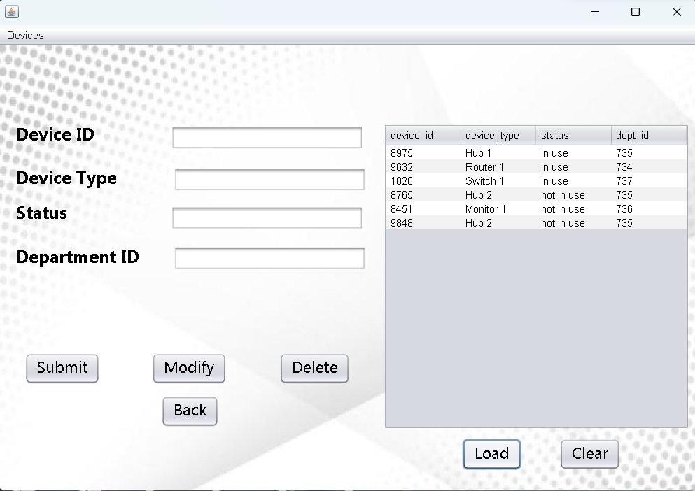

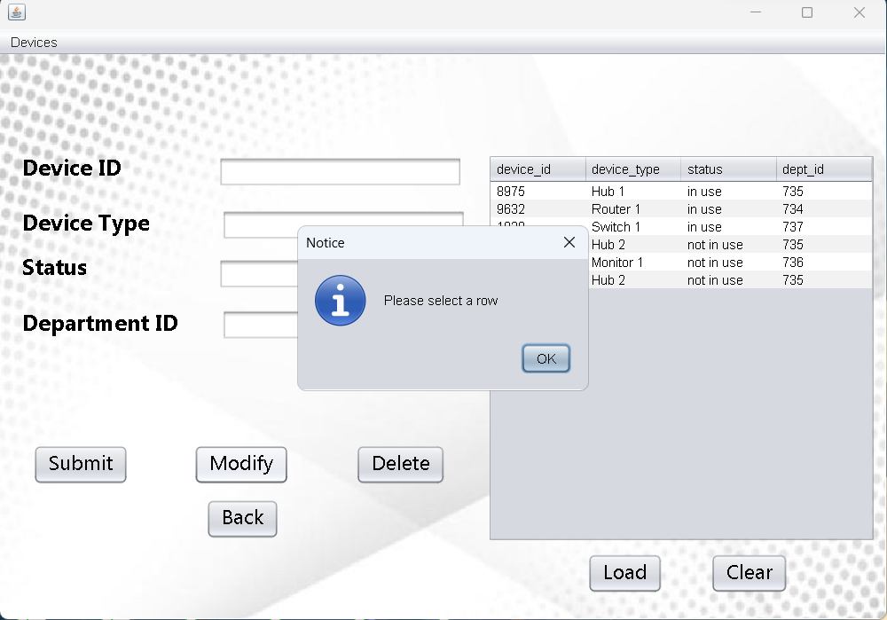

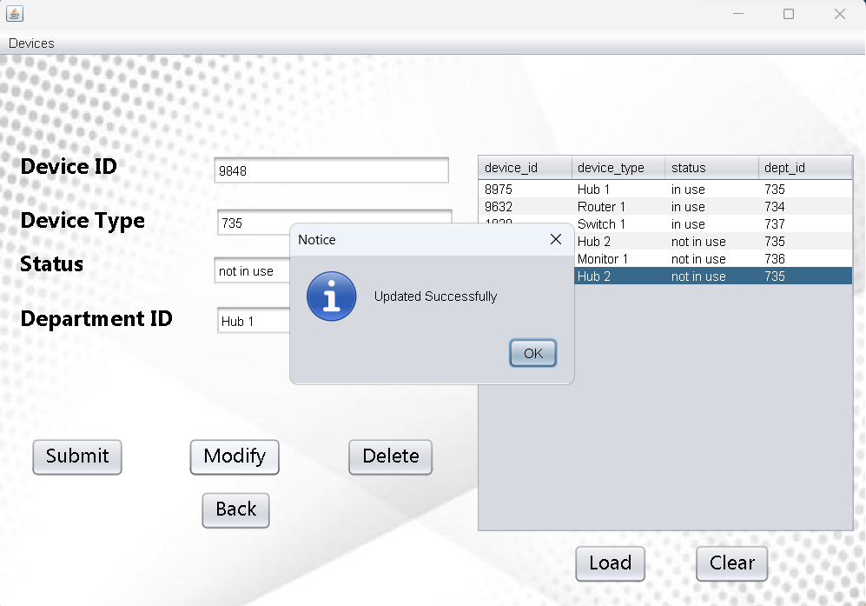

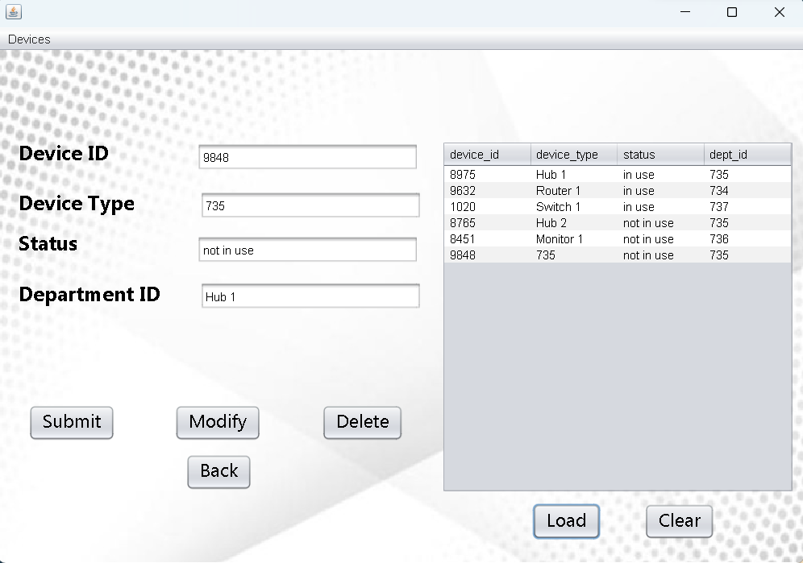

**Delete Device Table:**

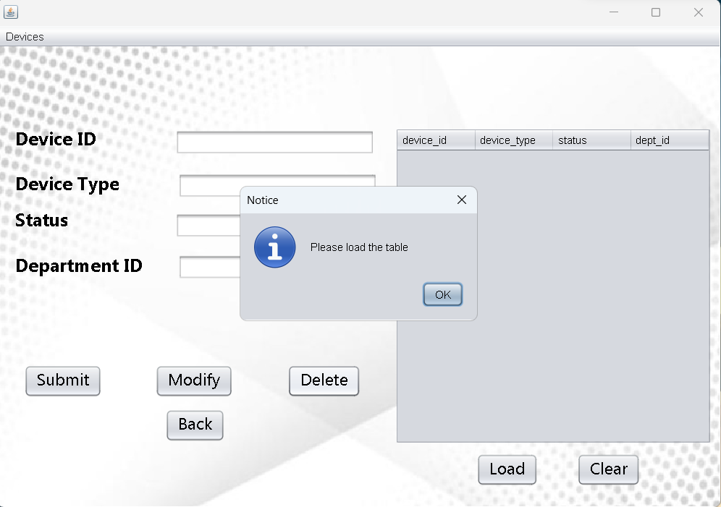

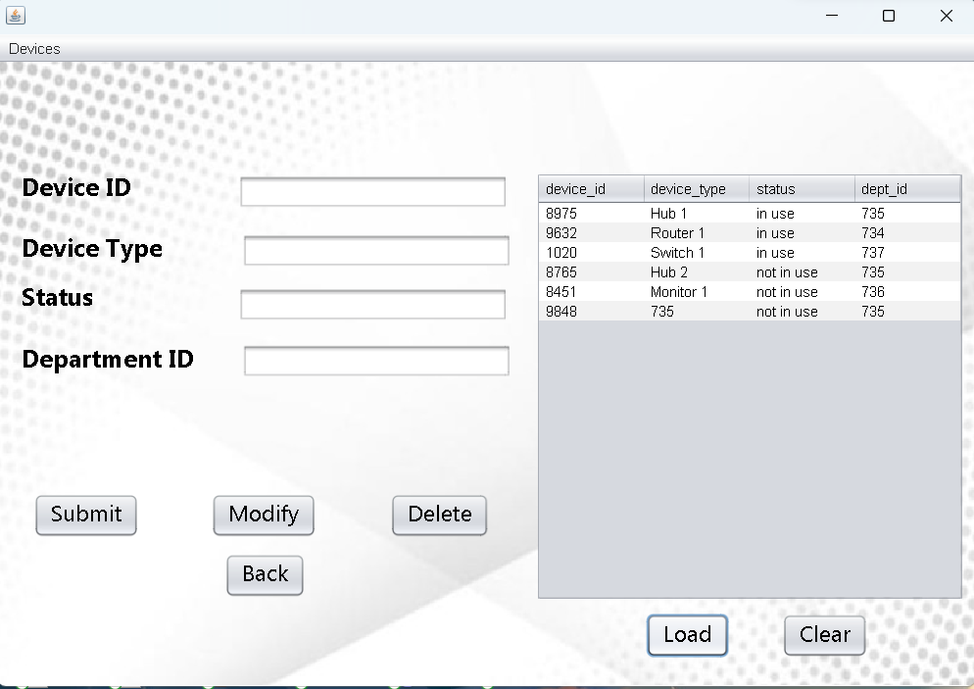

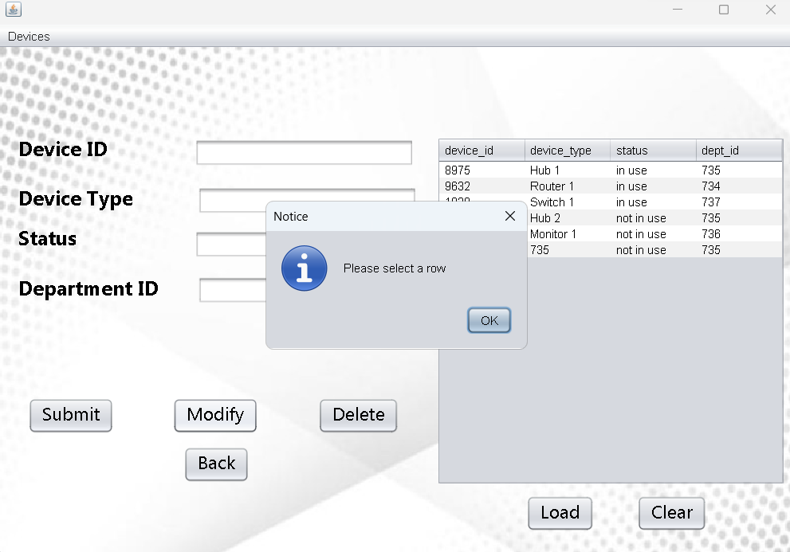

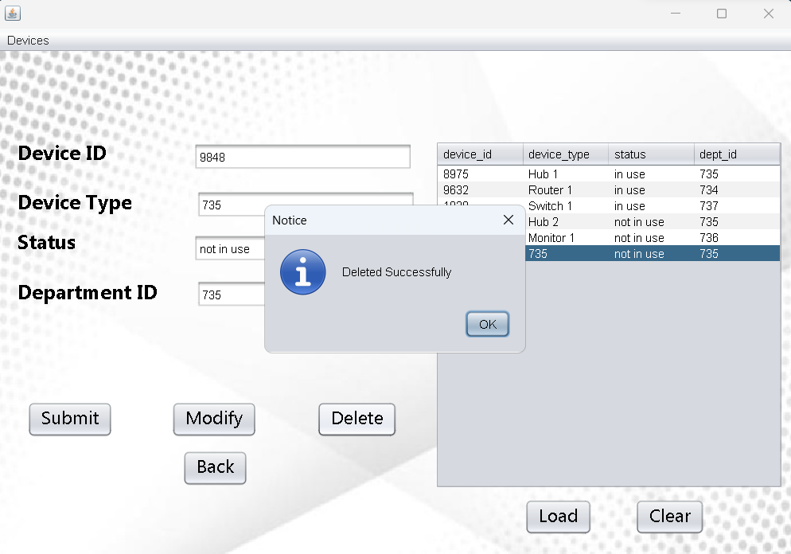

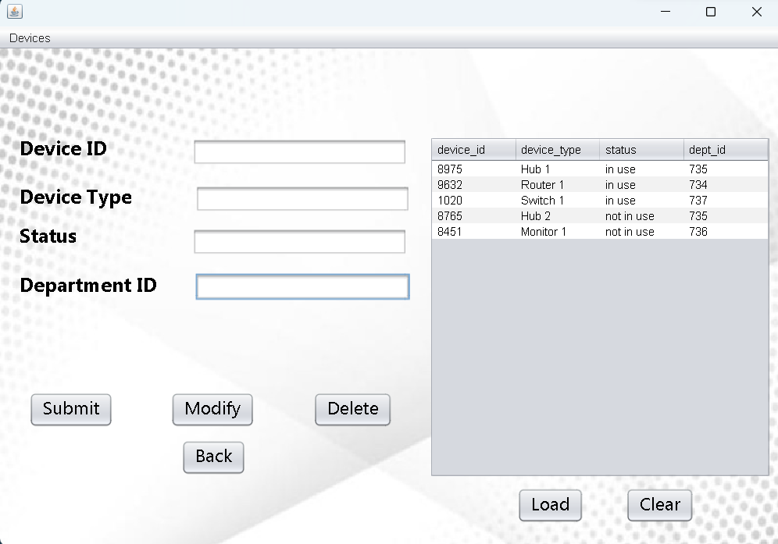

**Analysis Table:**



**Devices in use:**

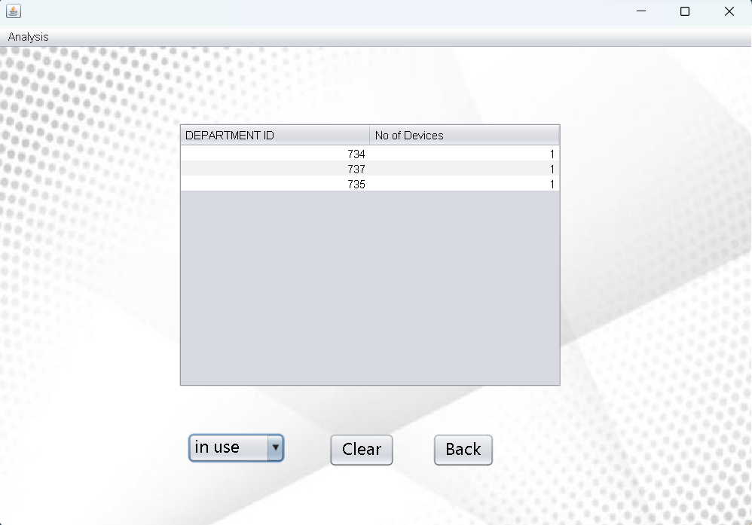

**Devices not in use:**

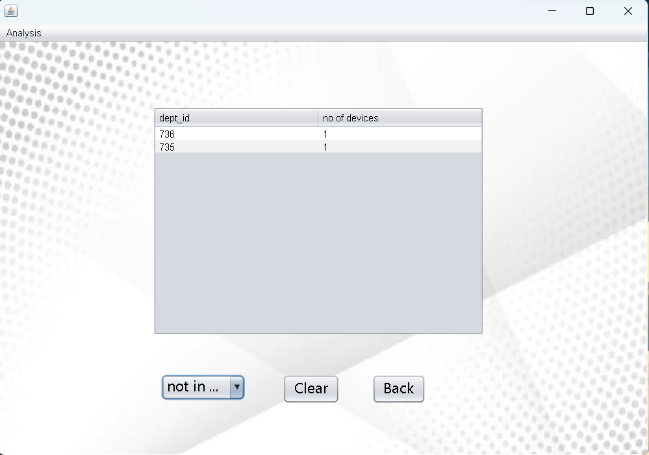

**The data entered in the above form is updated in the Run SQL database as:**

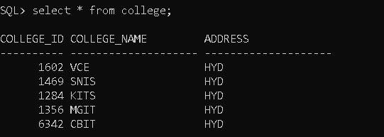

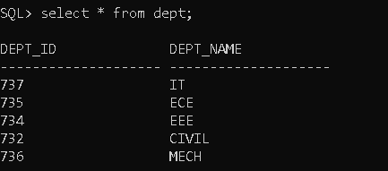

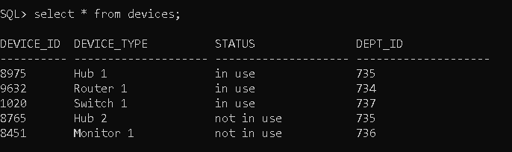

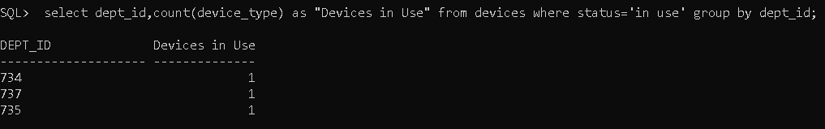

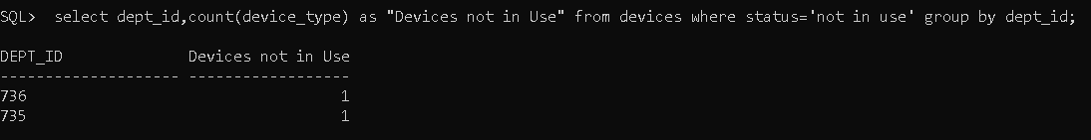

**RESULTS**

I have successfully completed the mini-project ***“College Network Hardware Database”*** .

## DISCUSSION AND FUTURE WORK

This project contains the basic information about college network hardware

database . It has a very basic user interface. Future scope would be to make the UI more appealing by using graphics. One more feature would be to add login page to

this interface.

## REFERENCES

* <https://docs.oracle.com/javase/7/docs/api/>
* <https://www.javatpoint.com/java-swing>
* <https://stackoverflow.com/>